

Assessment Report

Student name: Mark Beresford

Student Number: 471731221

Unit/Cluster: ICTWEB519_520

Assessment Number: 3



Contents

ML Strength – Health and Fitness 2

1. Project Requirements (Part 1) 2

Client Requirements 2

1.8 Wireframes 5

1.9 Styling Information 16

Typography 16

Iconography 16

Colour Scheme 17

2. Test, debug and validate (Part 3) 18

3.3 Validation 18

3.3 HTML Validation Testing 18

3.3 CSS Validation Testing 26

3.4 Browser/Device Testing 44

3.6 Accessibility Testing 65

3.7 Cyber security measures 70

Authentication process 70

Programmatically engineered solutions to avoid cyber-attacks 70

Internet protocols 71

Project Signoff 72

Appendices 72

References 72

ML Strength – Health and Fitness

Date: 12/05/2023

1. Project Requirements (Part 1)

Client Requirements

* 1. What does the client want to achieve with this web page?

To entice health conscience adults who are looking for something slightly different from a local gym, that doesn’t come on strong with selling gimmicks, and is geared to putting the needs of the customer first.

* 1. Who is the target audience for the page?

Health conscience local adults, who need a gym to be able to fit in around their schedule, and that offer a wide range of classes. Specific areas on offer are weight-loss, boxing and karate.

* 1. Are there any legislative or organisational standards that the designer/developer must comply with in the development of the web page?

|  |  |  |  |
| --- | --- | --- | --- |
| LEGAL OBLIGATION | | ACTIONS REQUIRED | SOURCE |
| Privacy Act | | * Inform your customers of what measures you have in place to protect their personal details, such as names, addresses and credit card details. * Check your privacy policy is compliant with Australian privacy law and is easily accessible on your website. | <https://www.business.qld.gov.au/running-business/digital-business/online-risk-security/legal-obligations> |
| Legal Obligations and jurisdictions | * Assess your online business activities and the geographic areas your business operates within and identify the legal obligations that apply. * Create a plan to ensure that all your business activities comply. * Conduct regular reviews or sign up for updates to make you aware of any changes, or seek professional advice. | | <https://www.business.qld.gov.au/running-business/digital-business/online-risk-security/legal-obligations> |
| Email Marketing | * Comply with the [Spam Act 2003(Cwlth)](https://www.legislation.gov.au/Series/C2004A01214) | | <https://www.legislation.gov.au/Details/C2016C00614> |
| Copyright | * Images and content to meet copyright requirements * Have permissions to use intellectual property | |  |
| Consumer Law | * Online advertising is not false or misleading. * Online reviews are genuine. * Uphold responsibilities to customers. * Comply with Australian Product/Mandatory safety laws | | <https://www.business.qld.gov.au/running-business/digital-business/online-risk-security/legal-obligations> |
| Website term of use | * A terms of use document that includes information on protecting your business ideas, disclaimers and rules applying to anyone who interacts with your website. | | <https://www.business.qld.gov.au/running-business/digital-business/online-risk-security/legal-obligations> |
| Terms and Conditions | * If you sell products online, include terms and conditions outlining the operations of your business sales, payment options, cancellation policies, consumer guarantees, and return and refund policies. * You should also have a process for customer complaints. | | <https://www.business.qld.gov.au/running-business/digital-business/online-risk-security/legal-obligations> |
| Business Information | * Contact details are included and easy to find | | <https://www.business.qld.gov.au/running-business/digital-business/online-risk-security/legal-obligations> |
| Client Agreement | * If you provide services online, include a client agreement. * This should contain information about payment, expectations, termination of the agreement, and the process for handling disputes | | <https://www.business.qld.gov.au/running-business/digital-business/online-risk-security/legal-obligations> |
| Electronic Transactions | * Provide payment mechanisms that are easy to use and give appropriate security. * Clearly explain the security and authentication methods you use so customers can assess any risks | | <https://www.business.qld.gov.au/running-business/digital-business/online-risk-security/legal-obligations> |
| Accessibility Standards | * Comply with WCAG 2.0/2.1 standards * Ensure that WCAG 2.1 success criteria support mobile use-cases * Define a clear conformance model for WCAG 2.1/dot.x releases * Ensure the conformance structure utilizes the WCAG 2.0 A / AA / AAA model | | <https://www.w3.org/TR/WCAG20/>  <https://w3c.github.io/wcag21/requirements/> |

1.8 Wireframes

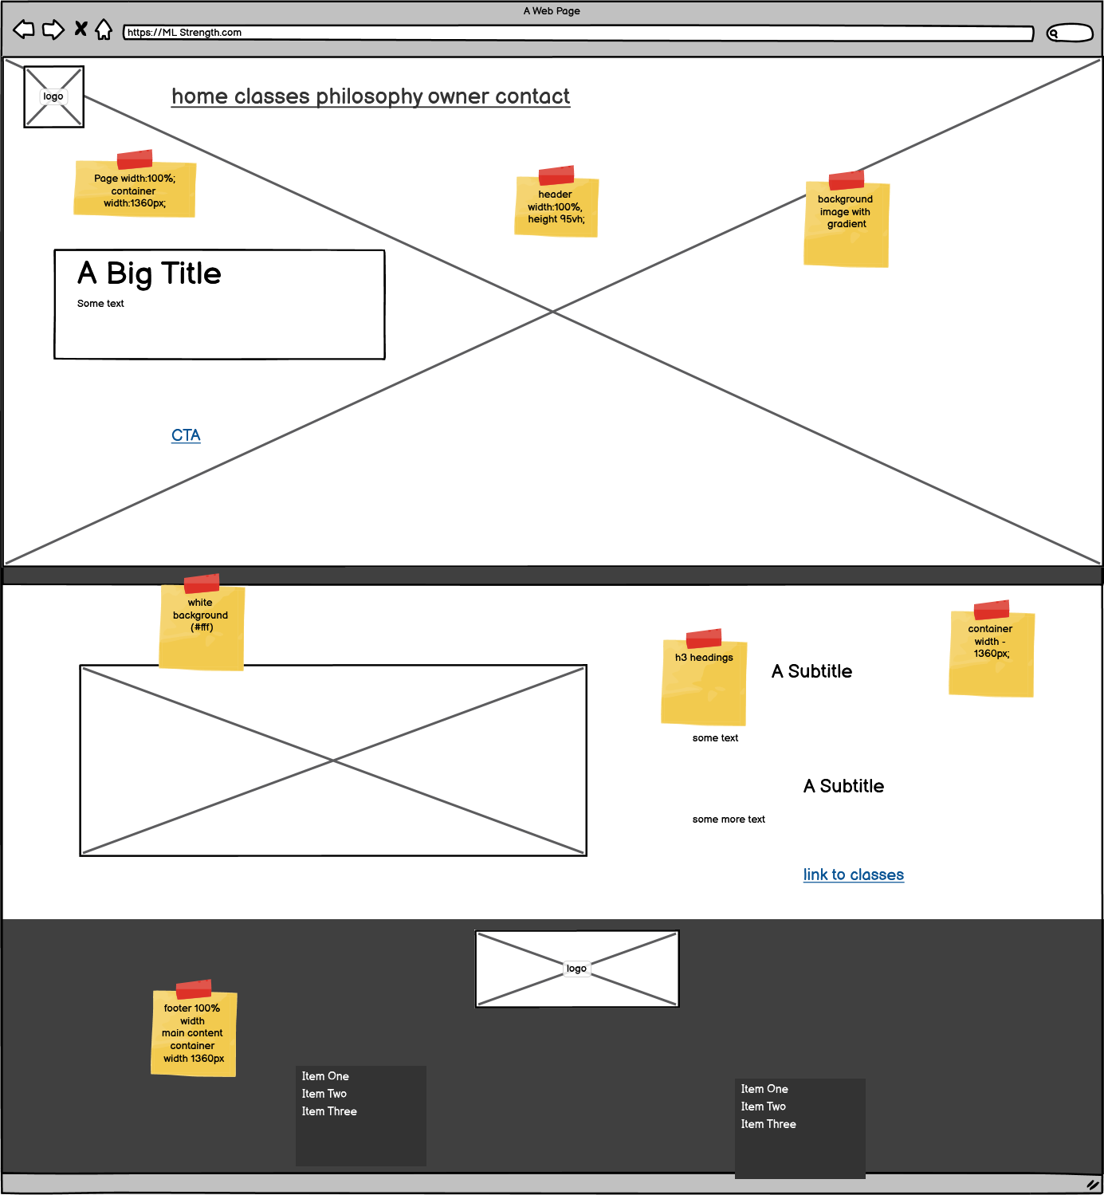

Desktop home-page

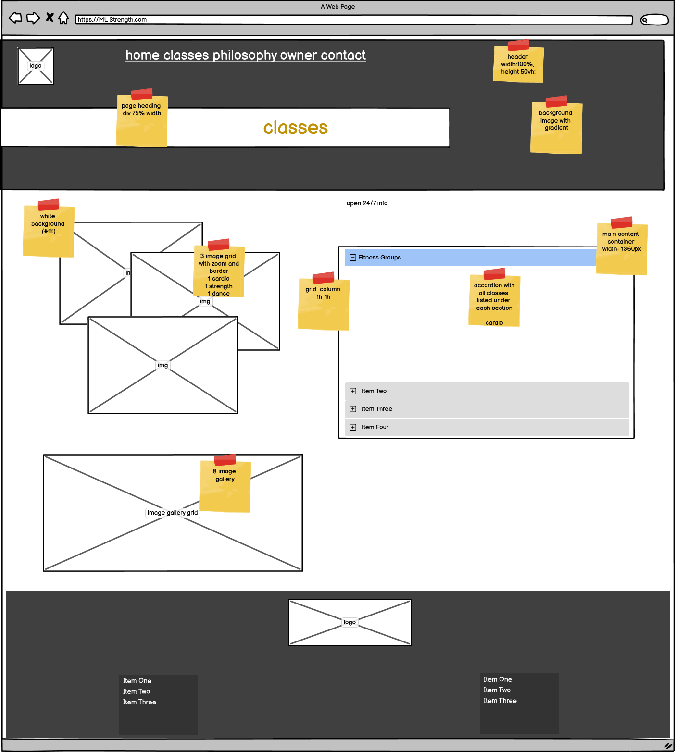

Desktop Classes page

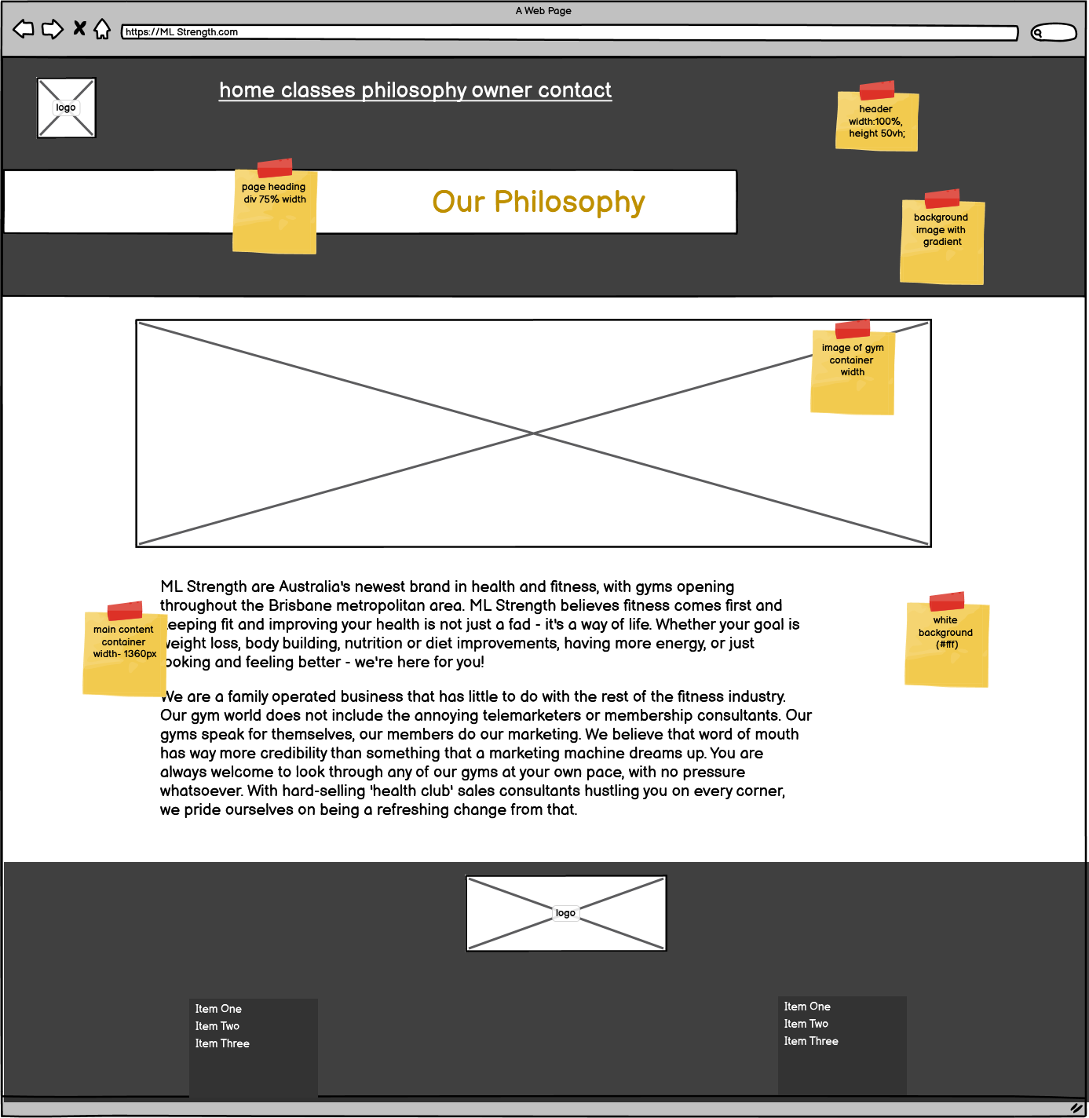

Desktop Philosophy page

Desktop Owner page

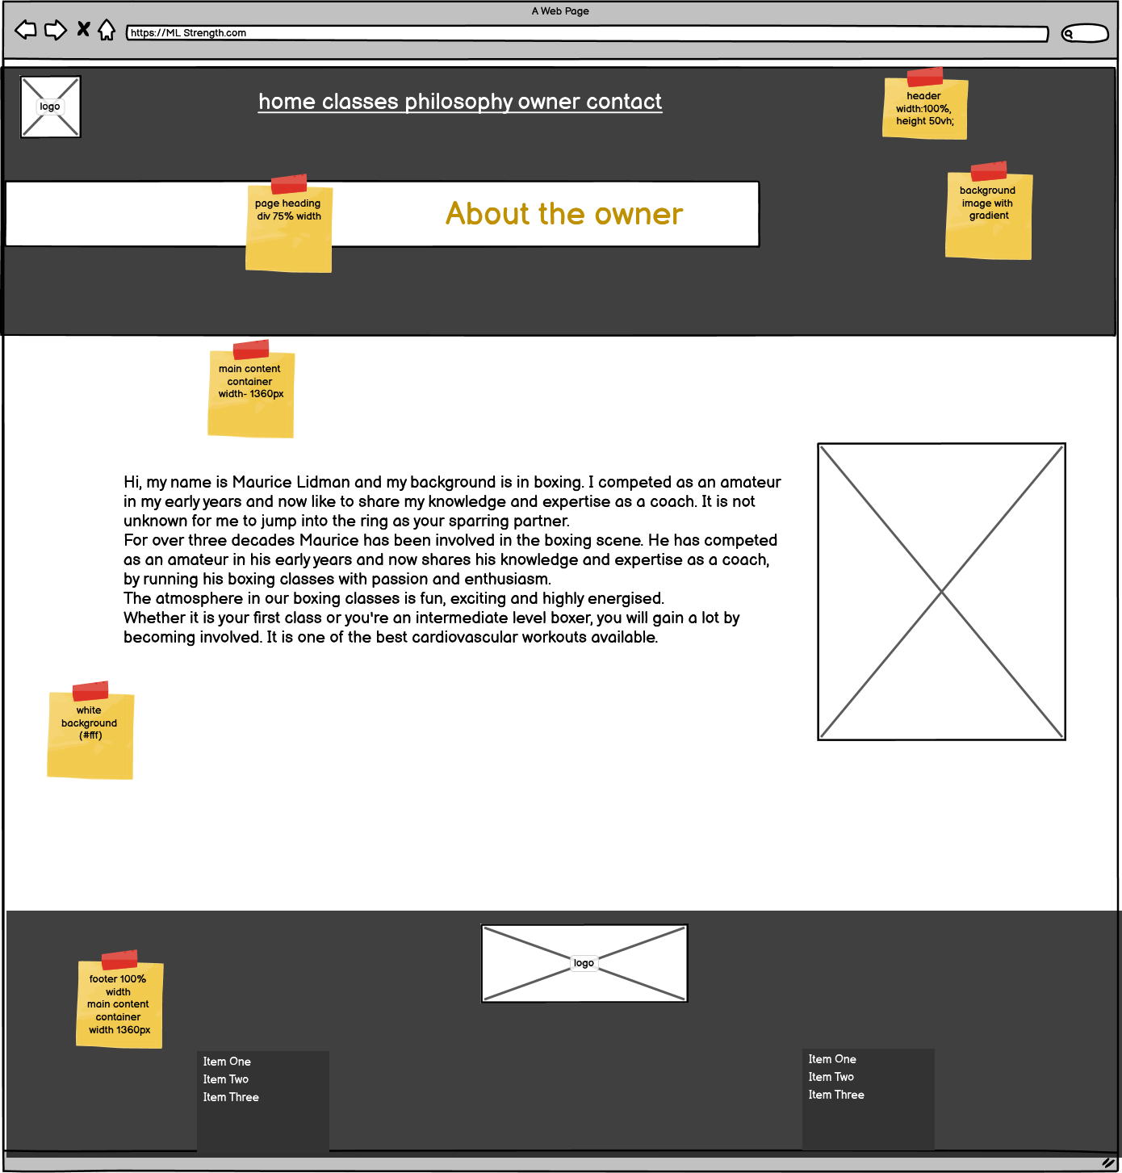

Desktop Contact form page

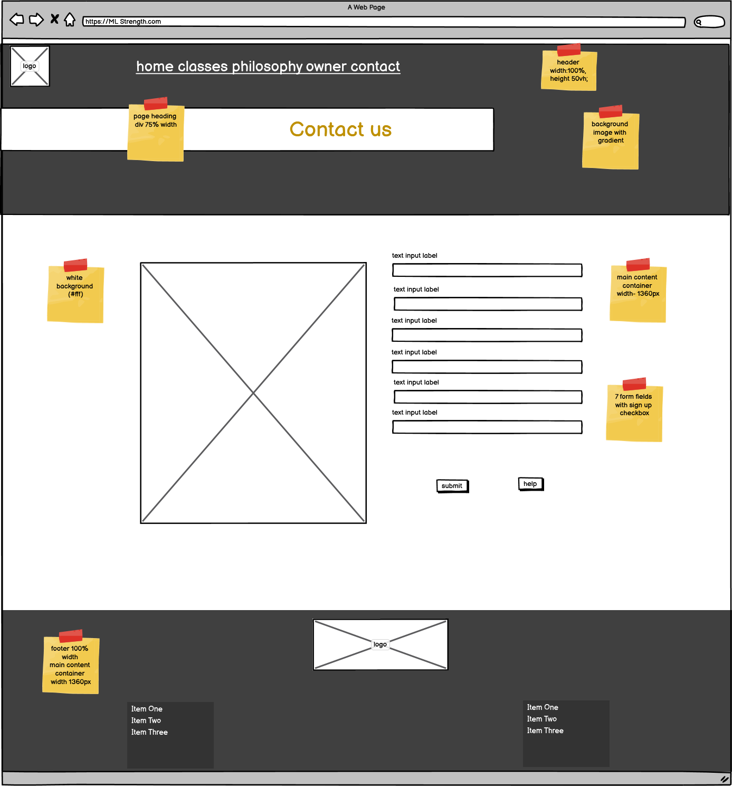

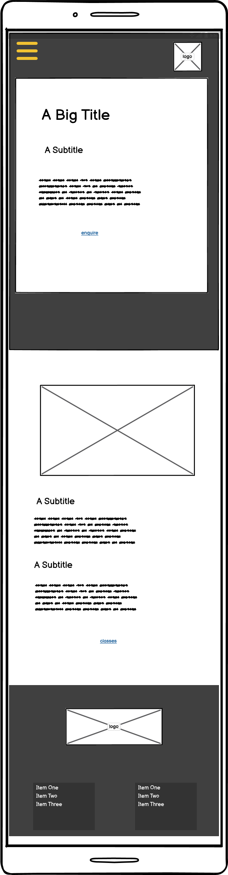

Mobile Index page

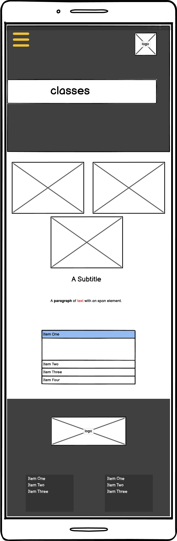

Mobile Classes page

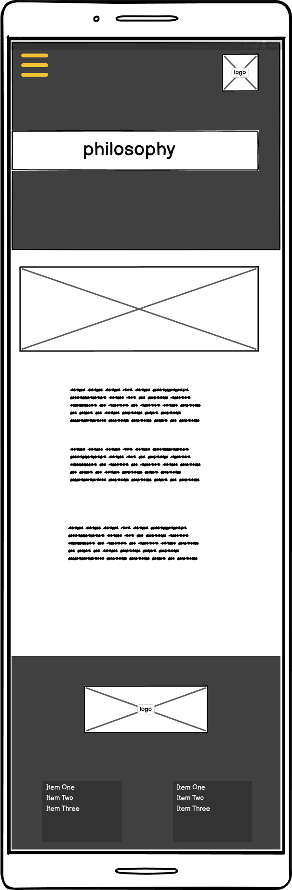

Mobile Philosophy page

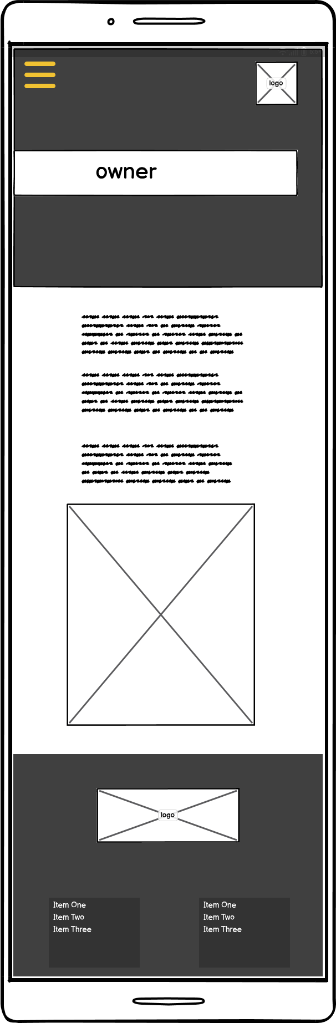

Mobile Owner page

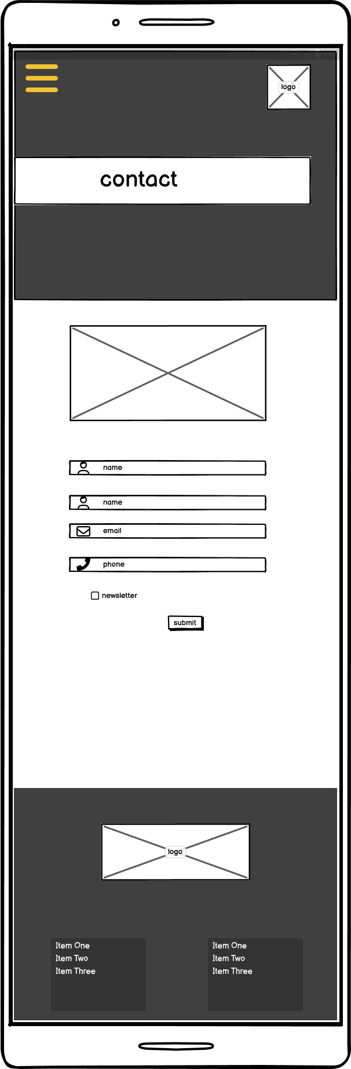

Mobile Contact page

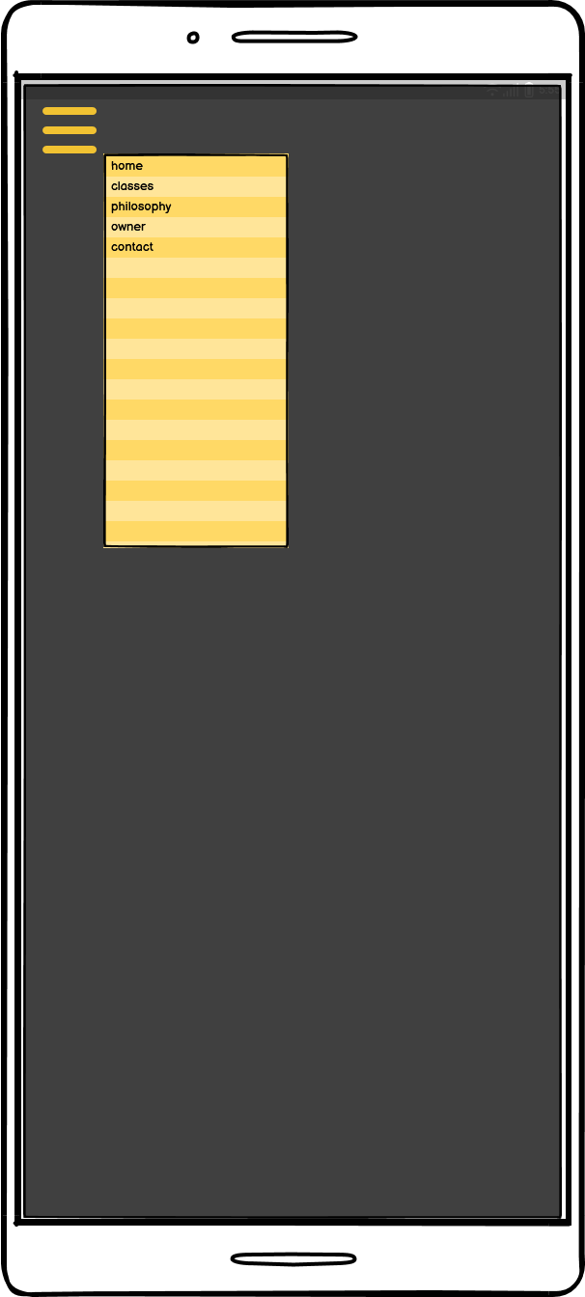

Pop-up Menu page

1.9 Styling Information

Typography

|  |  |
| --- | --- |
| Main Styles | |
| Title/Heading 1 | 60px - 40px |
| Heading 2 | 30px |
| Heading 3 | 25px - 30px |
| Heading 4 | 20px - 25px |
| Link: link, active and hover | 20px |
| Paragraph | 20px |
| Fig caption | 18px/14px/12px |
| Unordered Lists | 14px |
| Font-family | |
| Headings | Palanquin Dark |
| Paragraphs/list | Lato |
| Back-up | Sans serif |

Iconography

The iconography format style I chose is from the font-awesome, as they could be added using CSS content,. These can then be coloured using color in CSS, and sized using font-size in CSS.

Below is listed the specific icons I chose and why:

|  |  |
| --- | --- |
|  | To represent the name in the form field |
|  | To represent the email address in the form field |
|  | To represent the phone number in the form field |

Colour Scheme

|  |  |
| --- | --- |
| **COLOUR SCHEMES** | |
| **PAGE CONTENT** | |
| **Background:**  Header background will be a gradient fading from left to right using #212529  Main page background will be white #fff  Footer background will be set using background color to #0a0b0c. | **Text:**  Headings and text will use a dark grey #212529 except the main title headings which will use #e9e9ea as they have a dark background |
| **Buttons/Links:**  Buttons will be set using the secondary colour orange #e8590c.  Nav Links will be white #fff as they are set on a black background.  CTA links will use the secondary colour orange #e8590c.  **Icons:**  Form icons will use the secondary colour orange #e8590c. | **FORMS:**  **Background:**  White background with orange border  **Labels:**  Page Text colour  *required as secondary orange colour  **Input fields:**  Grey background  Placeholder slightly darker grey  **Submit Button:**  Secondary orange colour.  Help link grey background with secondary orange text. |
| **SCHEME**  Colour Palette |
| **White space** | Used for main content only |

2. Test, debug and validate (Part 3)

3.3 Validation

3.3 HTML Validation Testing

Index page Test - 1

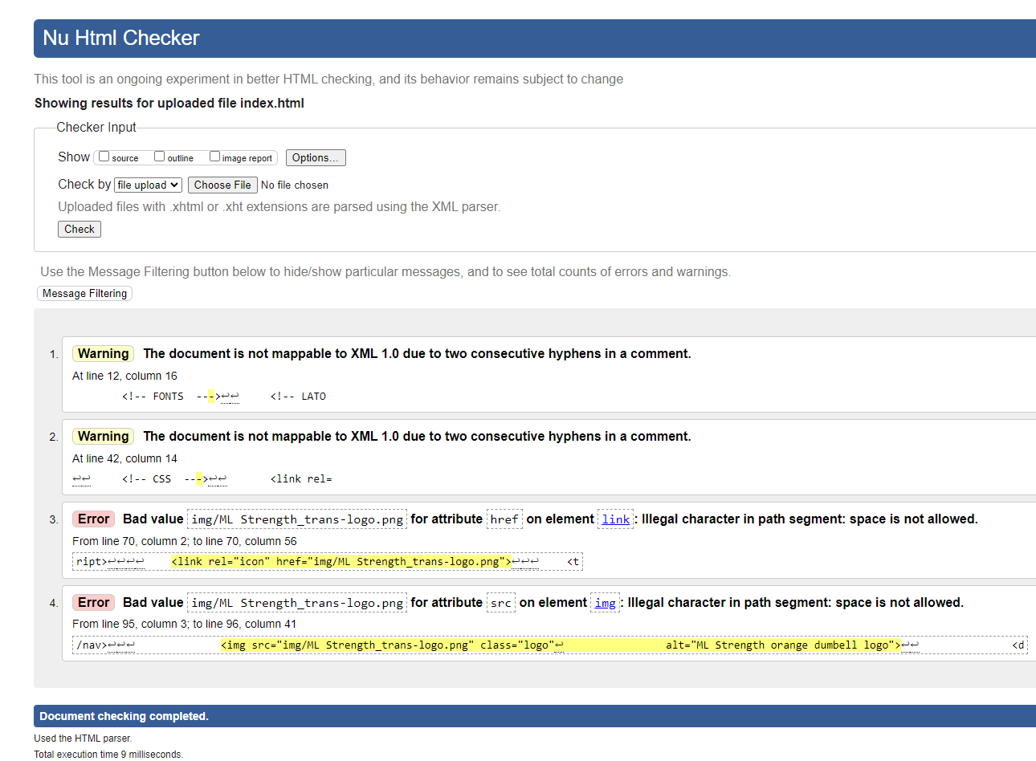

Index Page Test -2

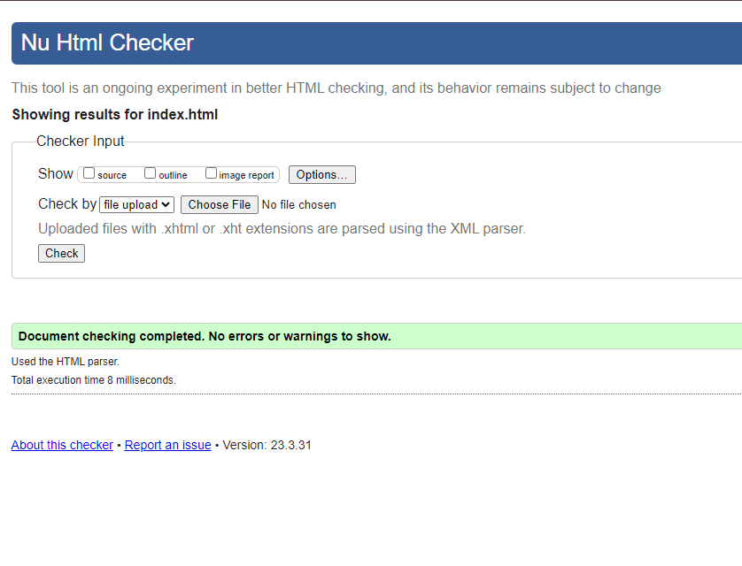

Classes Page Test -1

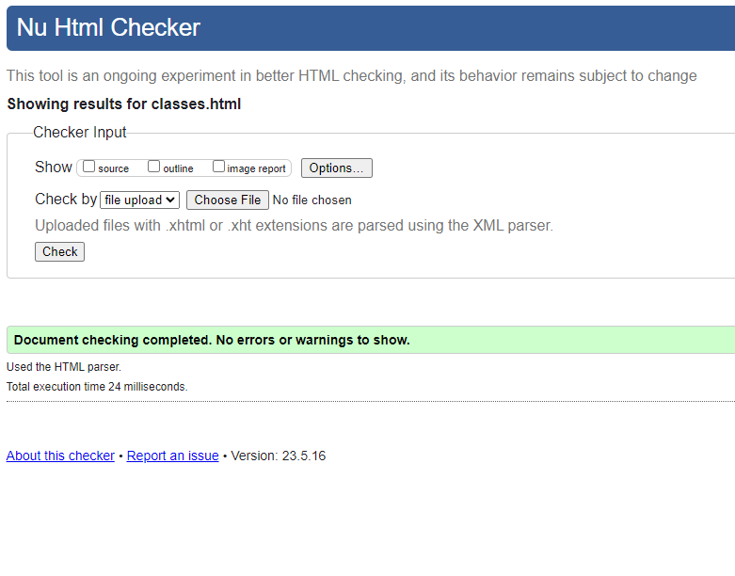

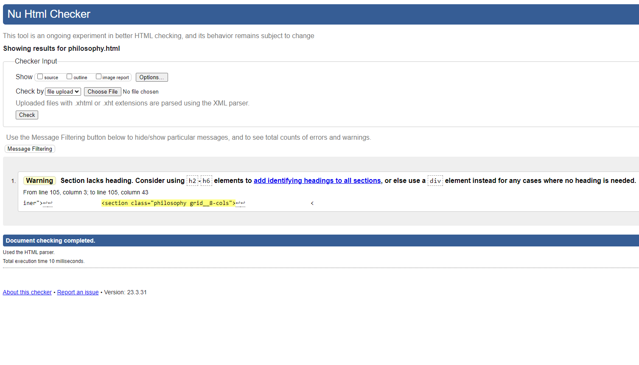Philosophy Page Test -1

Philosophy Page Test-2

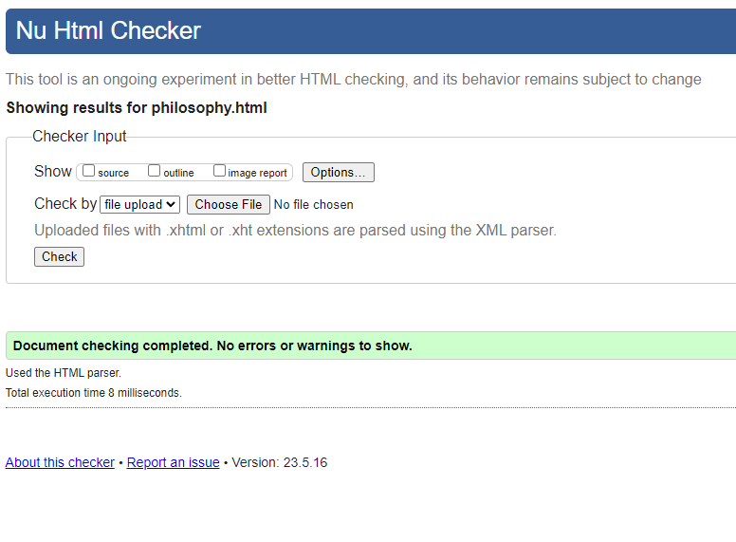

Owner Page Test -1

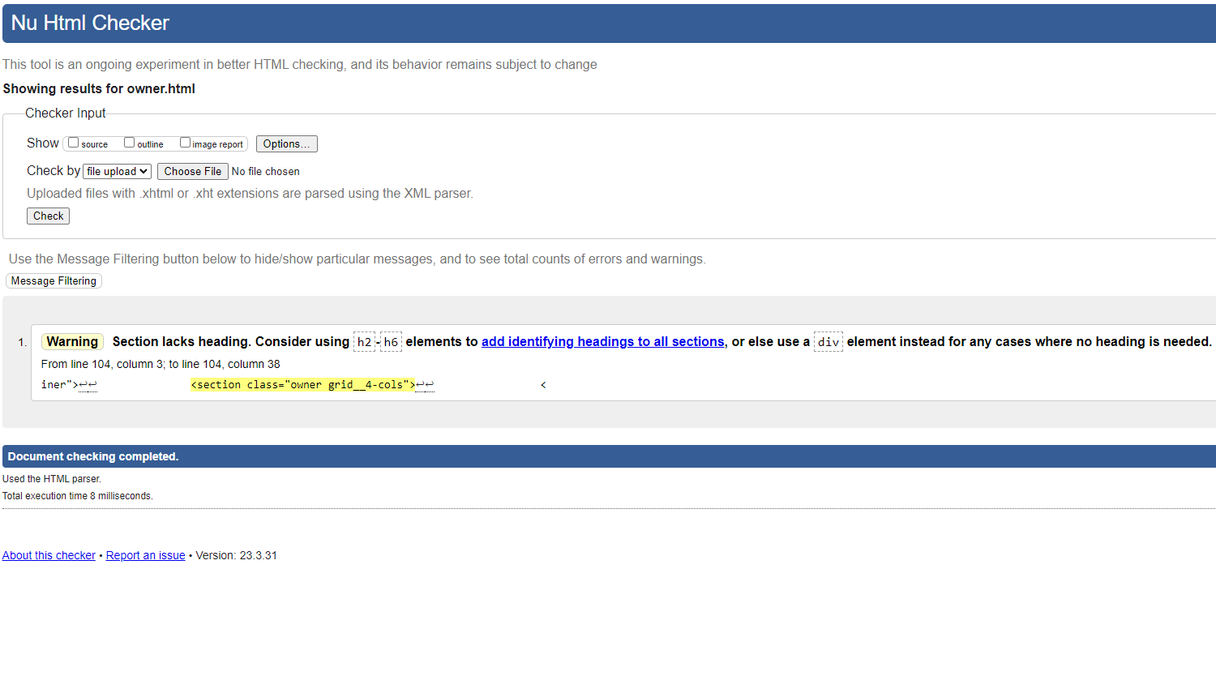

Owner Page Test -2

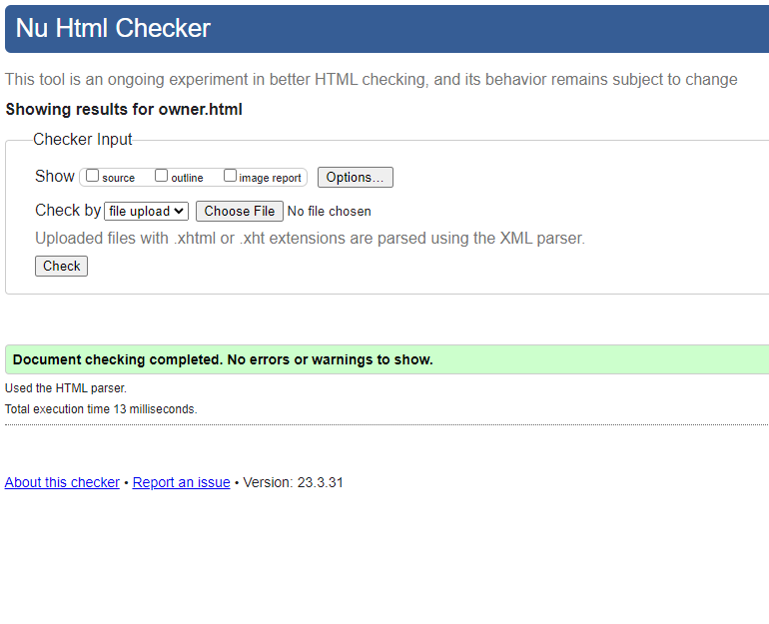

Contact Page Test -1 Screen 1

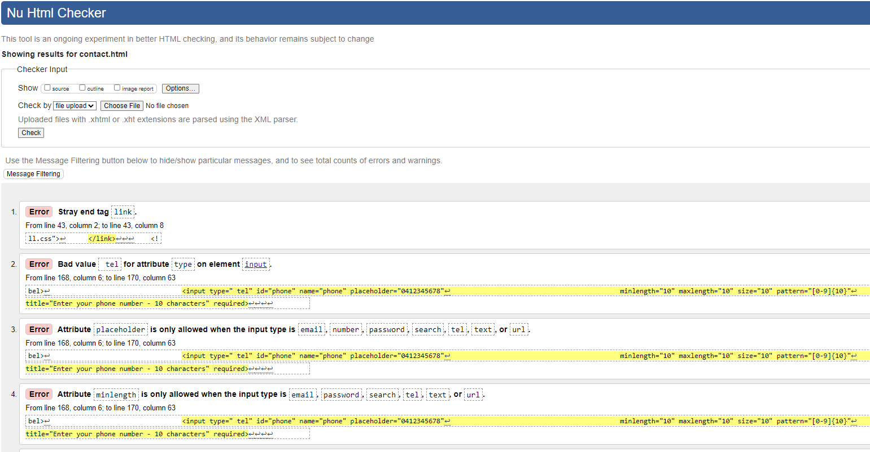

Contact Page Test -1 Screen 2

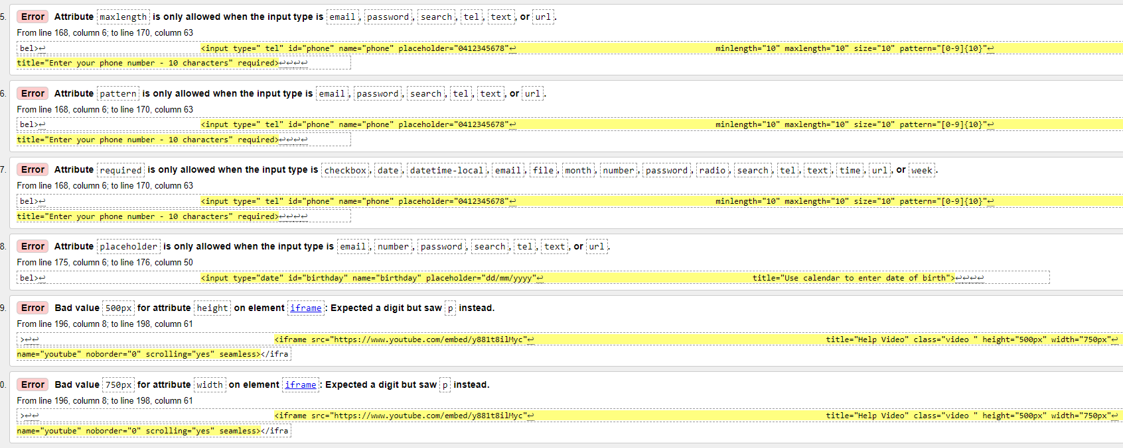

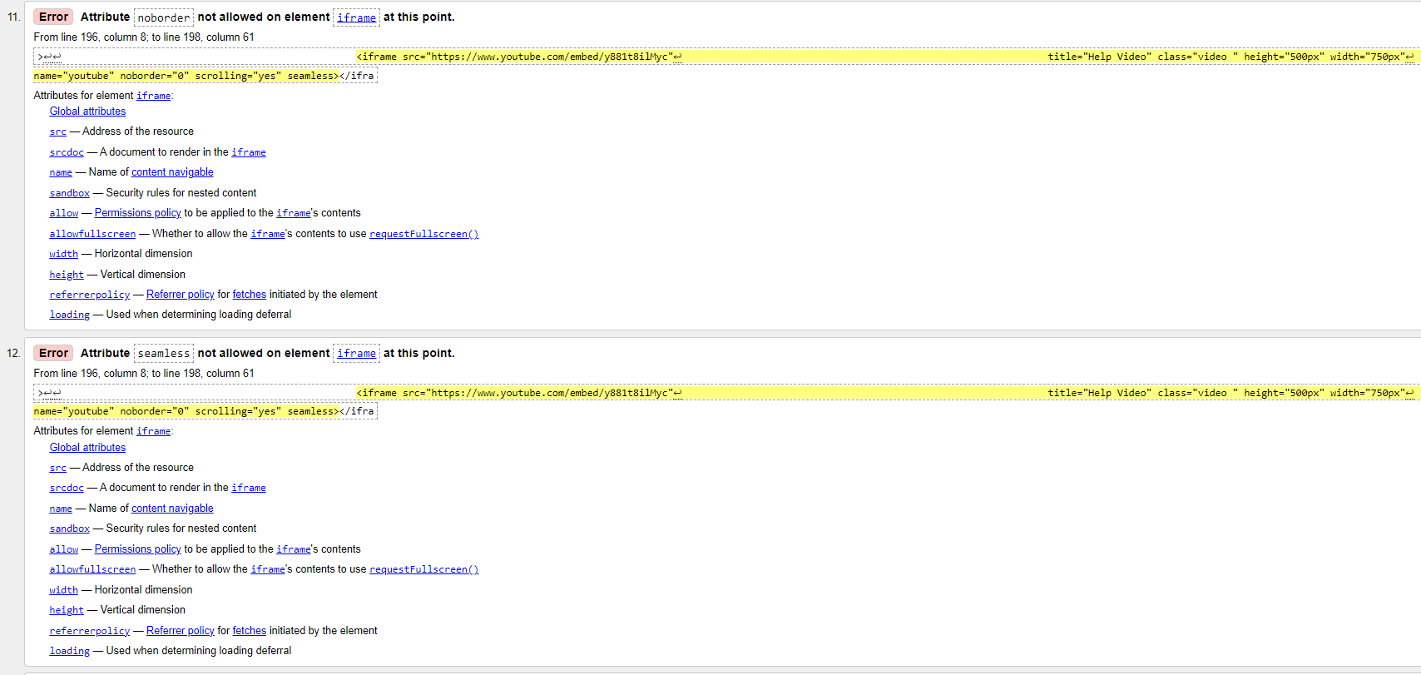Contact Page Test -1 Screen 3

Contact Page Test -1 Screen 4

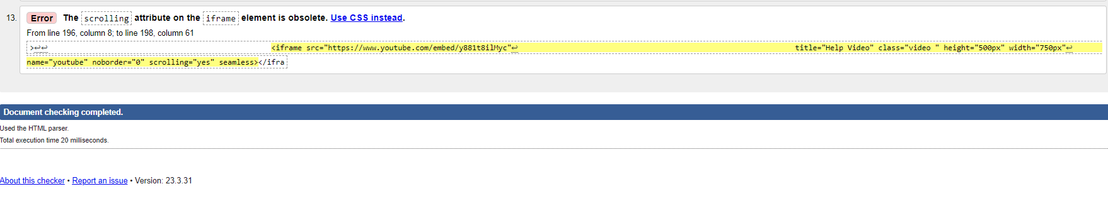

Contact Page Test -2

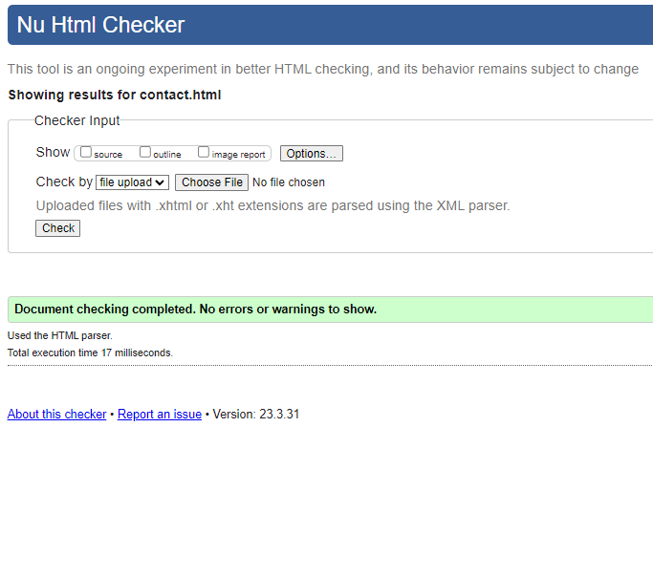

navigation.html test-1

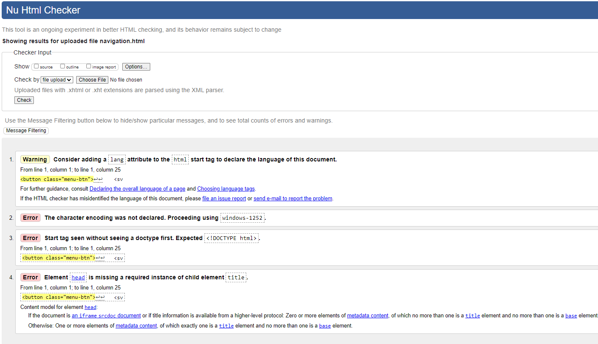

*All issues relate to common file injection and are not needed for this purpose

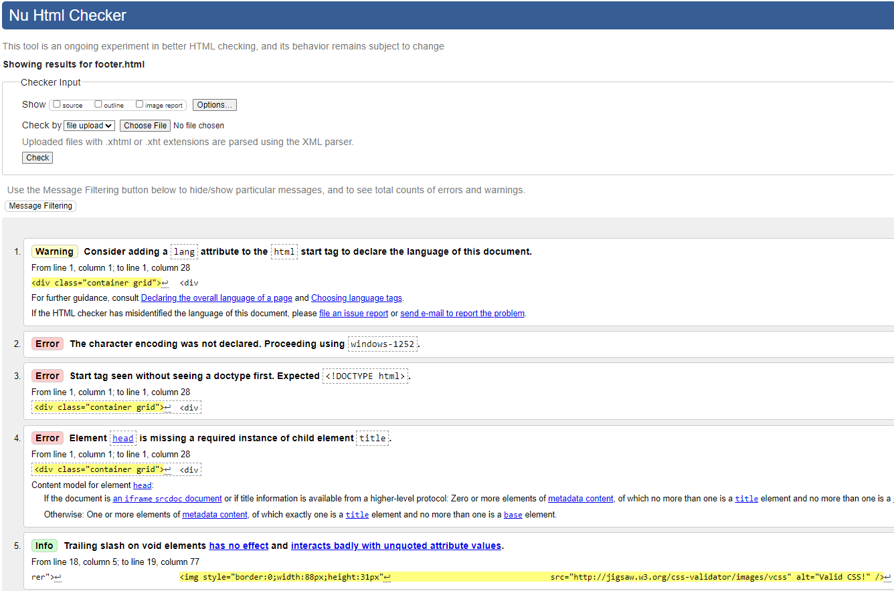Footer.html – Test-1

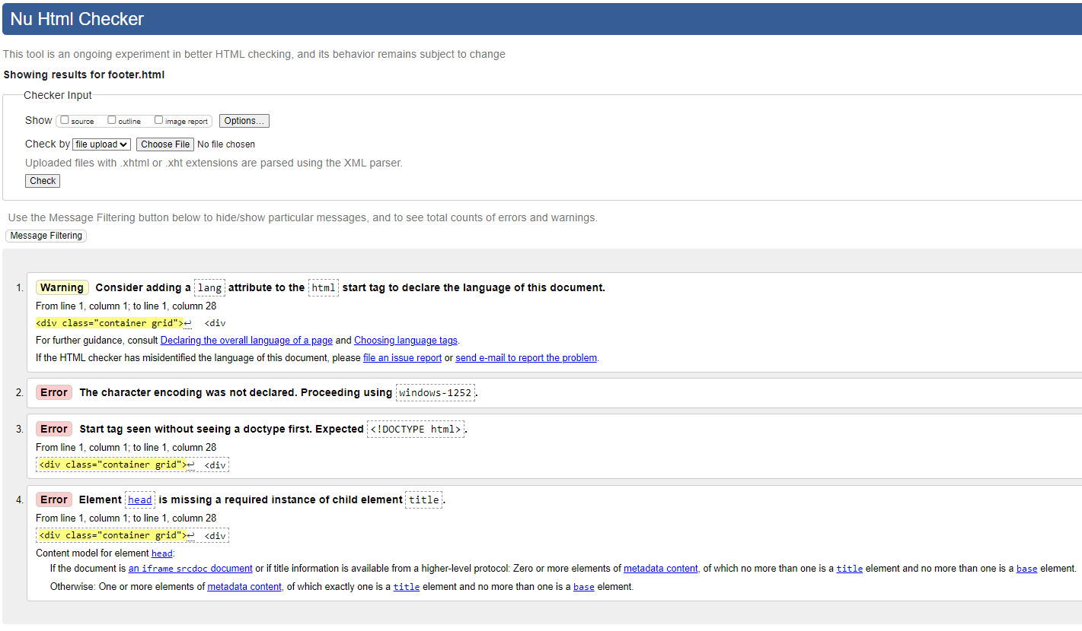Footer.html – Test-2

*All issues relate to common file injection and are not needed for this purpose

3.3 CSS Validation Testing

style.css Test -1

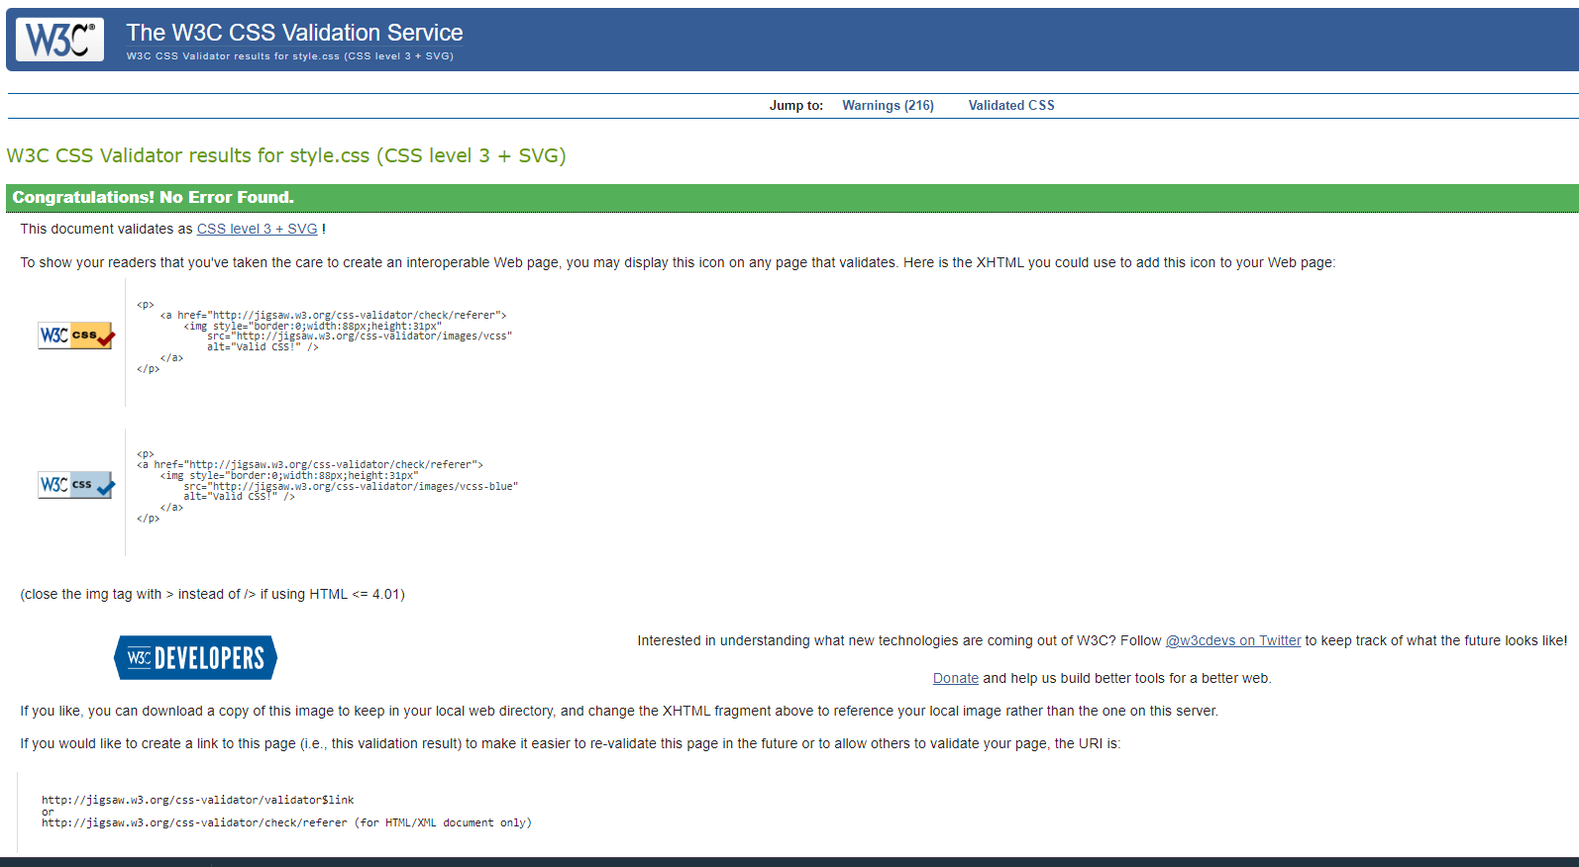

3.4 Browser/Device Testing

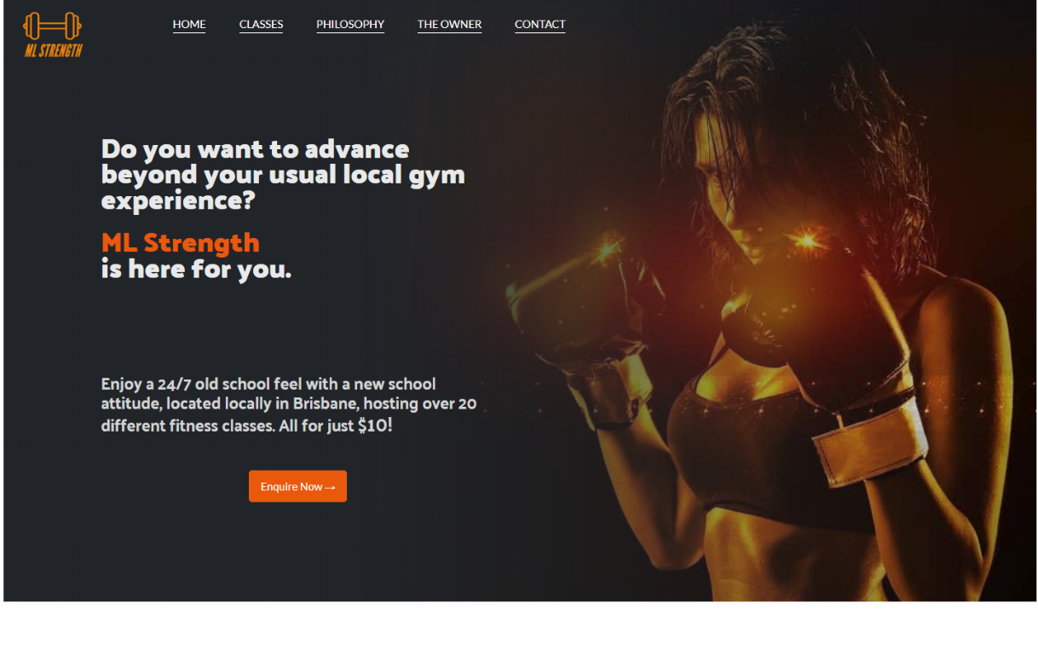

Figure 1 – index.html -Desktop PC

Google Chrome V 113.0.5672.127 (Official Build) (64-bit)

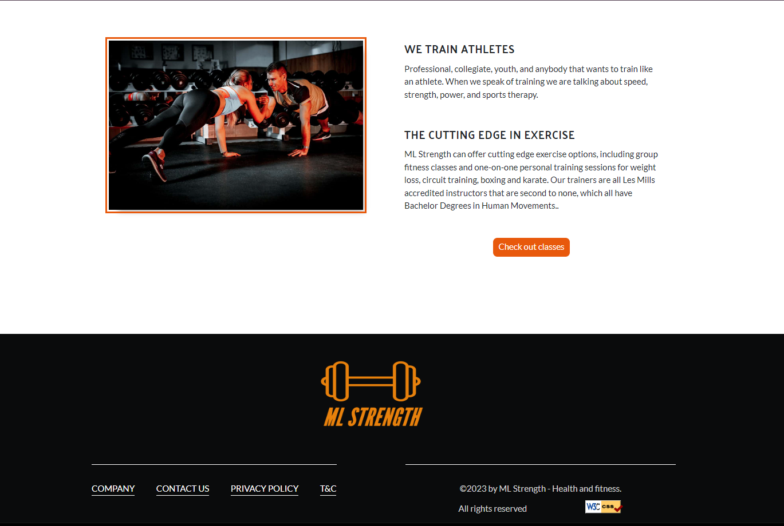

Figure 2 – index.html -Desktop PC

Google Chrome V 113.0.5672.127 (Official Build) (64-bit)

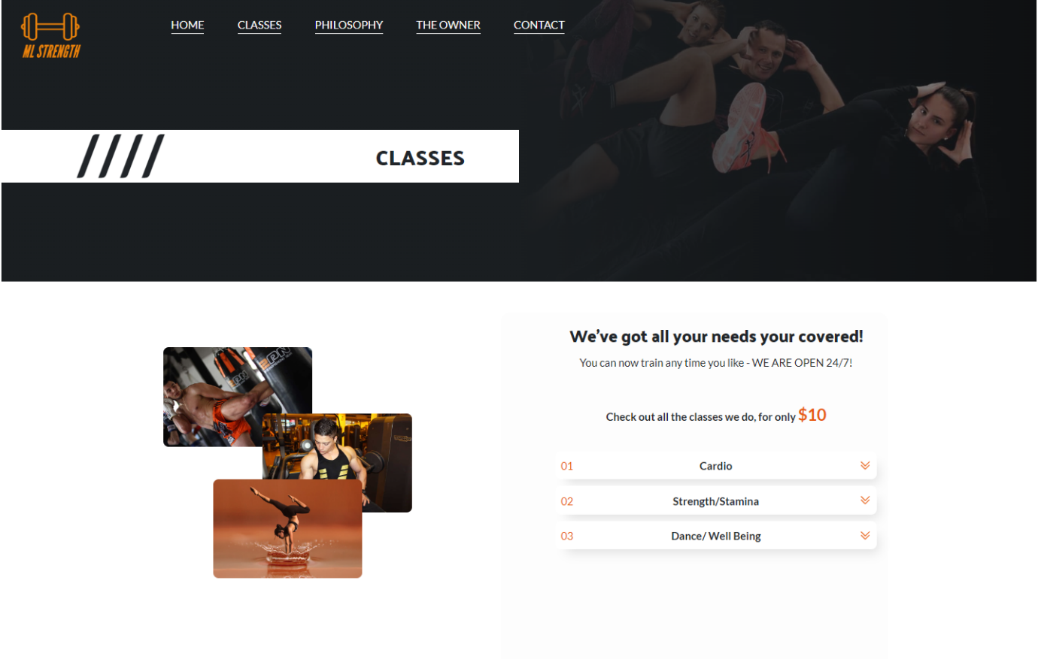Figure 3 – classes.html -Desktop PC

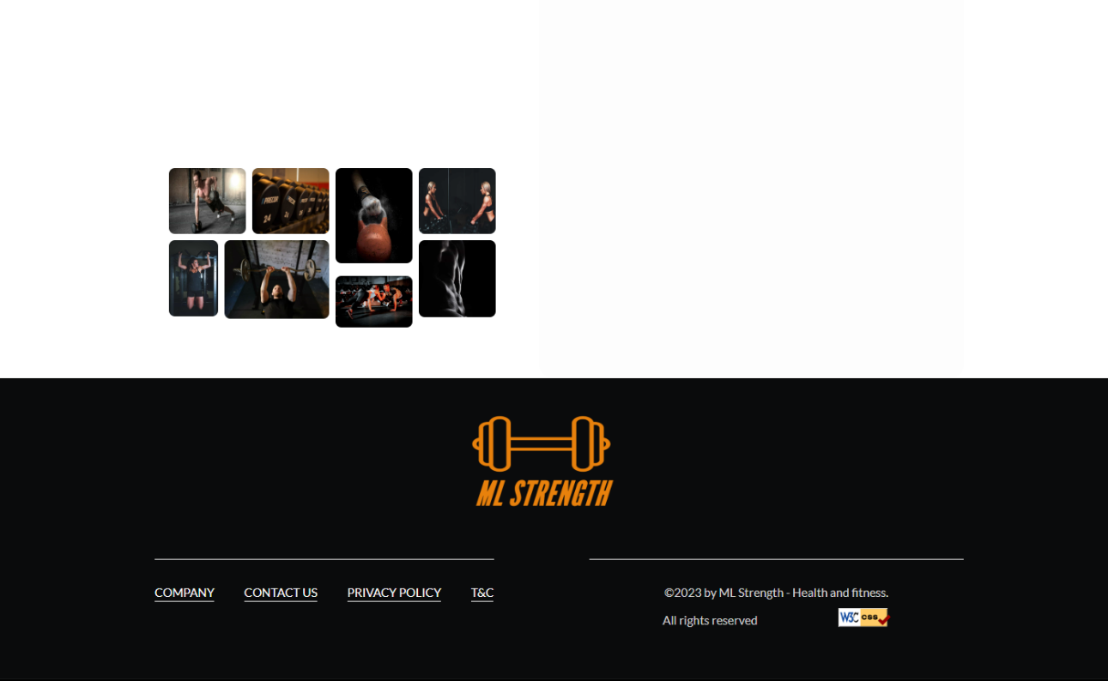Google Chrome V 113.0.5672.127 (Official Build) (64-bit)

Figure 4 – classes.html -Desktop PC

Google Chrome V 113.0.5672.127 (Official Build) (64-bit)

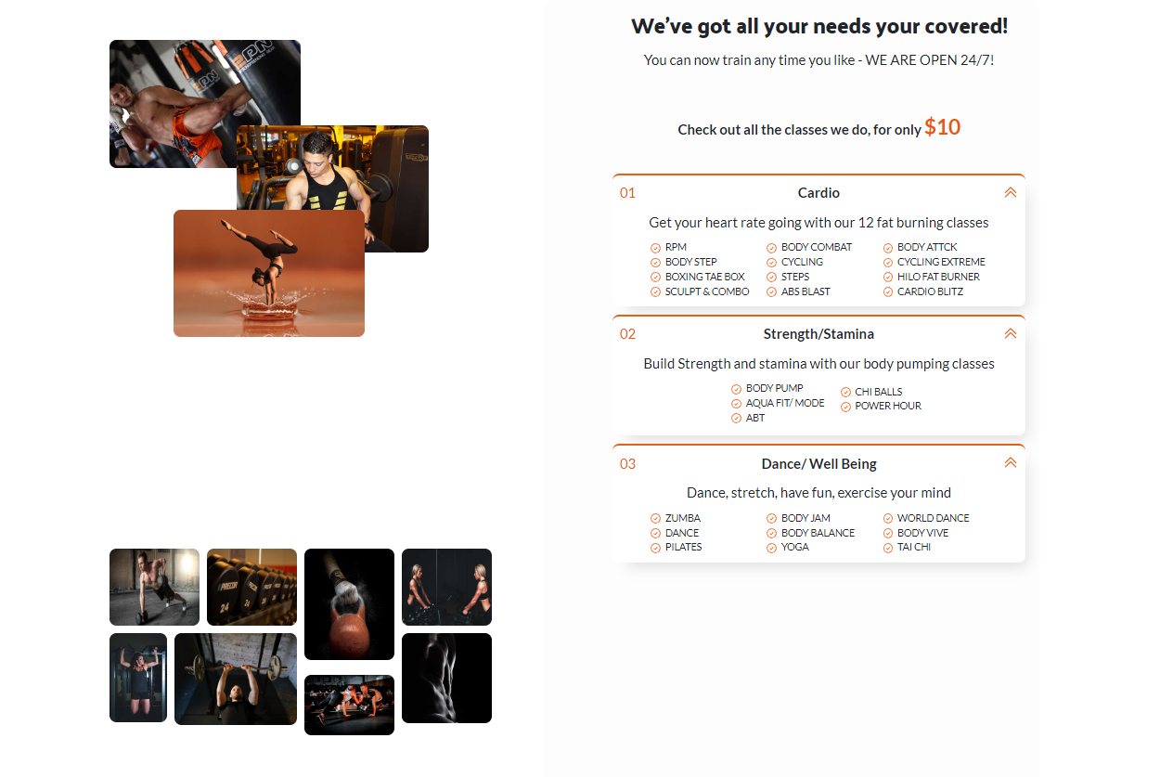

Figure 5 – classes.html “Accordion” -Desktop PC

Google Chrome V 113.0.5672.127 (Official Build) (64-bit)

Figure 6 – philosophy.html -Desktop PC

Google Chrome V 113.0.5672.127 (Official Build) (64-bit)

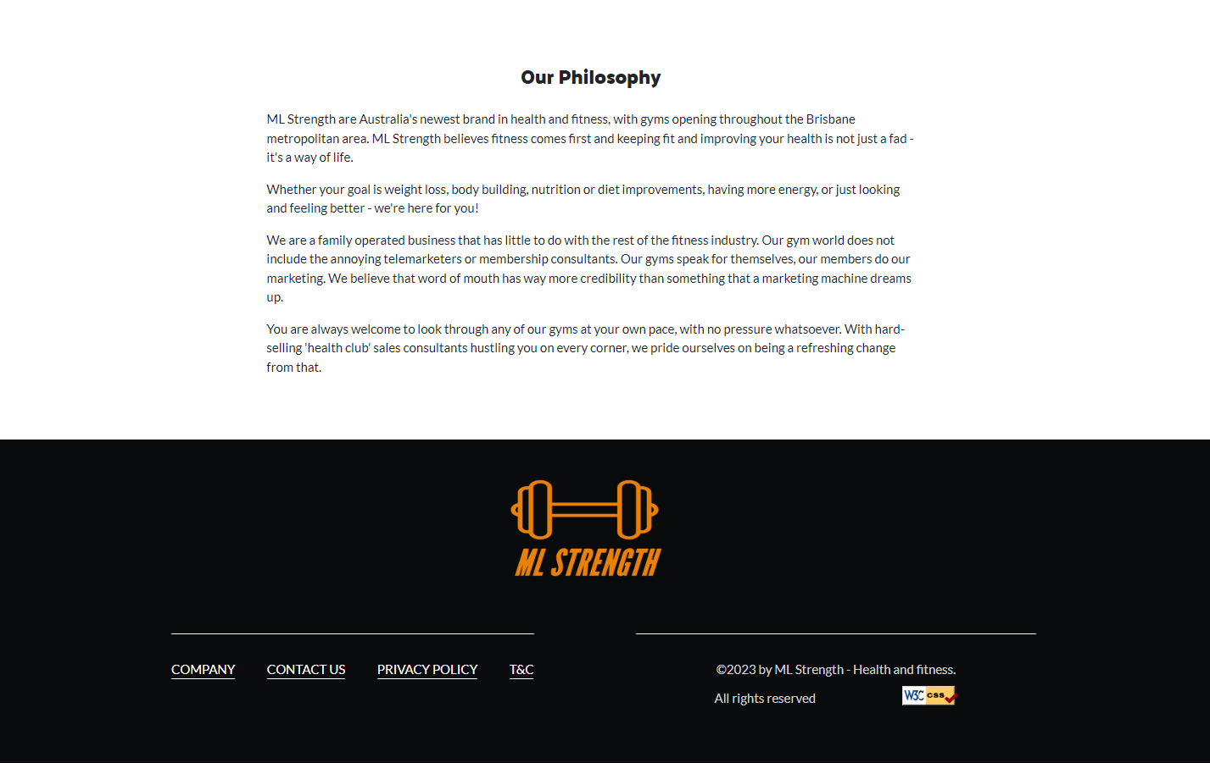

Figure 7 – philosophy.html -Desktop PC

Google Chrome V 113.0.5672.127 (Official Build) (64-bit)

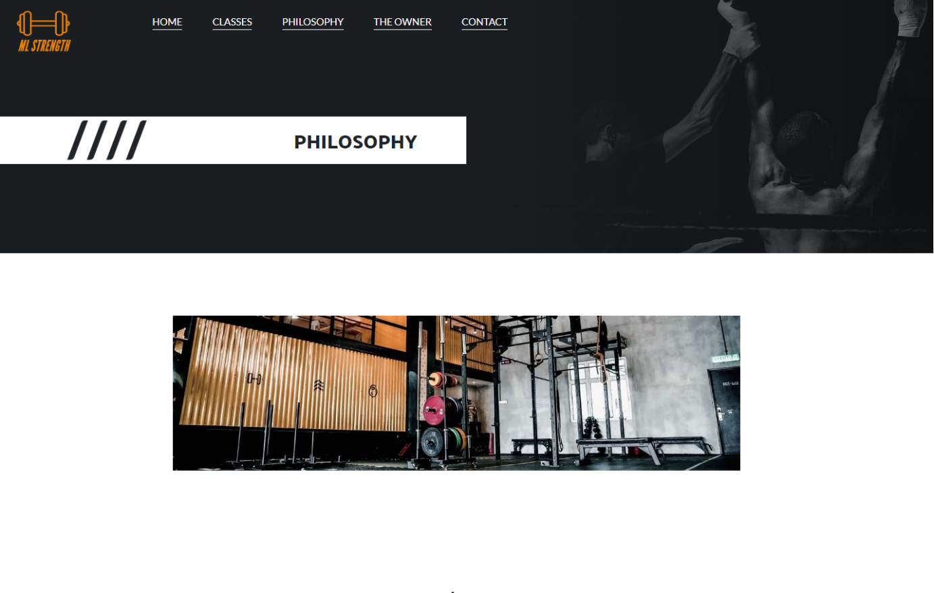

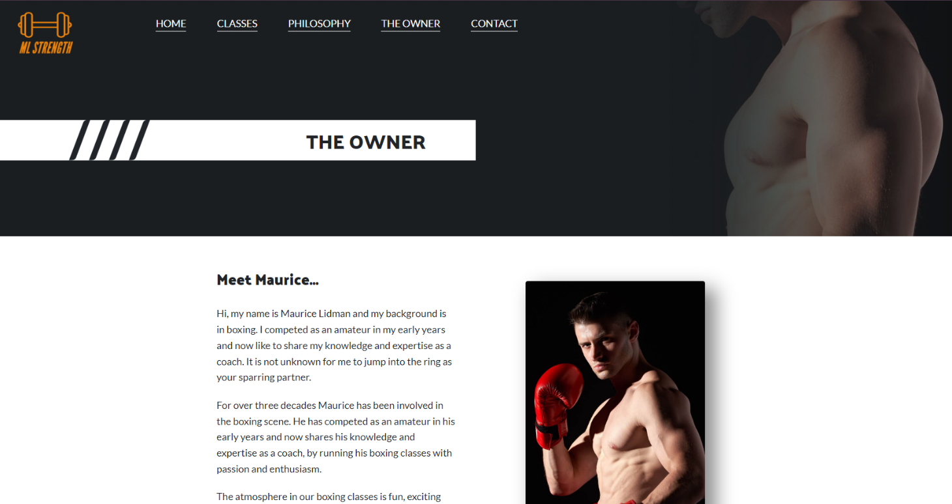

Figure 8 – owner.html -Desktop PC

Google Chrome V 113.0.5672.127 (Official Build) (64-bit)

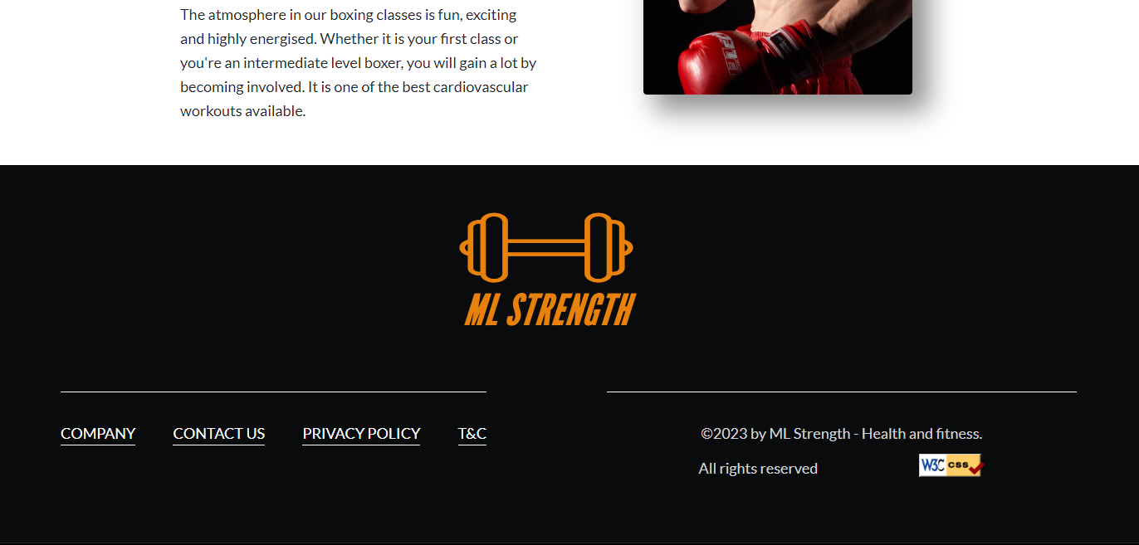

Figure 9 – owner.html -Desktop PC

Google Chrome V 113.0.5672.127 (Official Build) (64-bit)

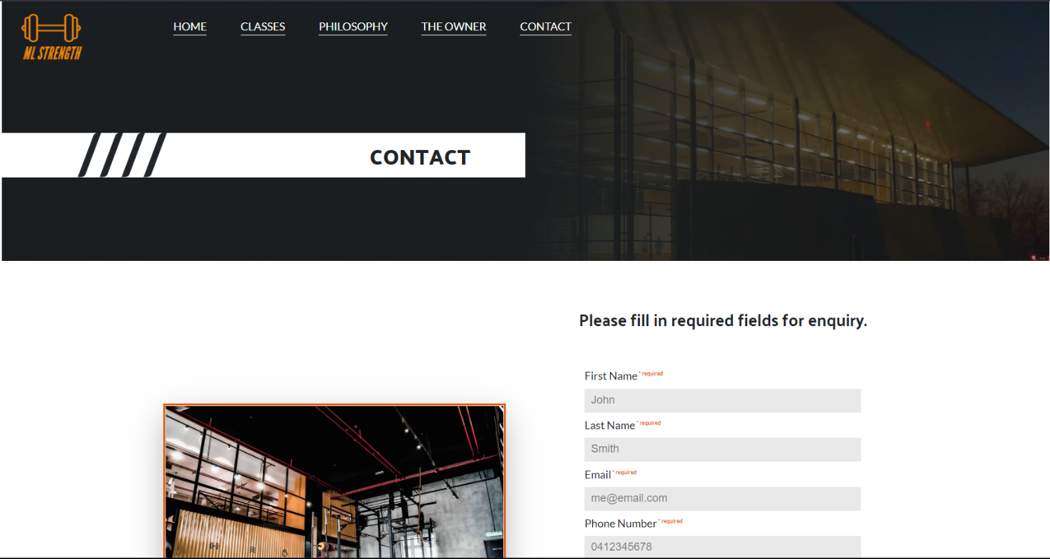

Figure 10 – contact.html -Desktop PC

Google Chrome V 113.0.5672.127 (Official Build) (64-bit)

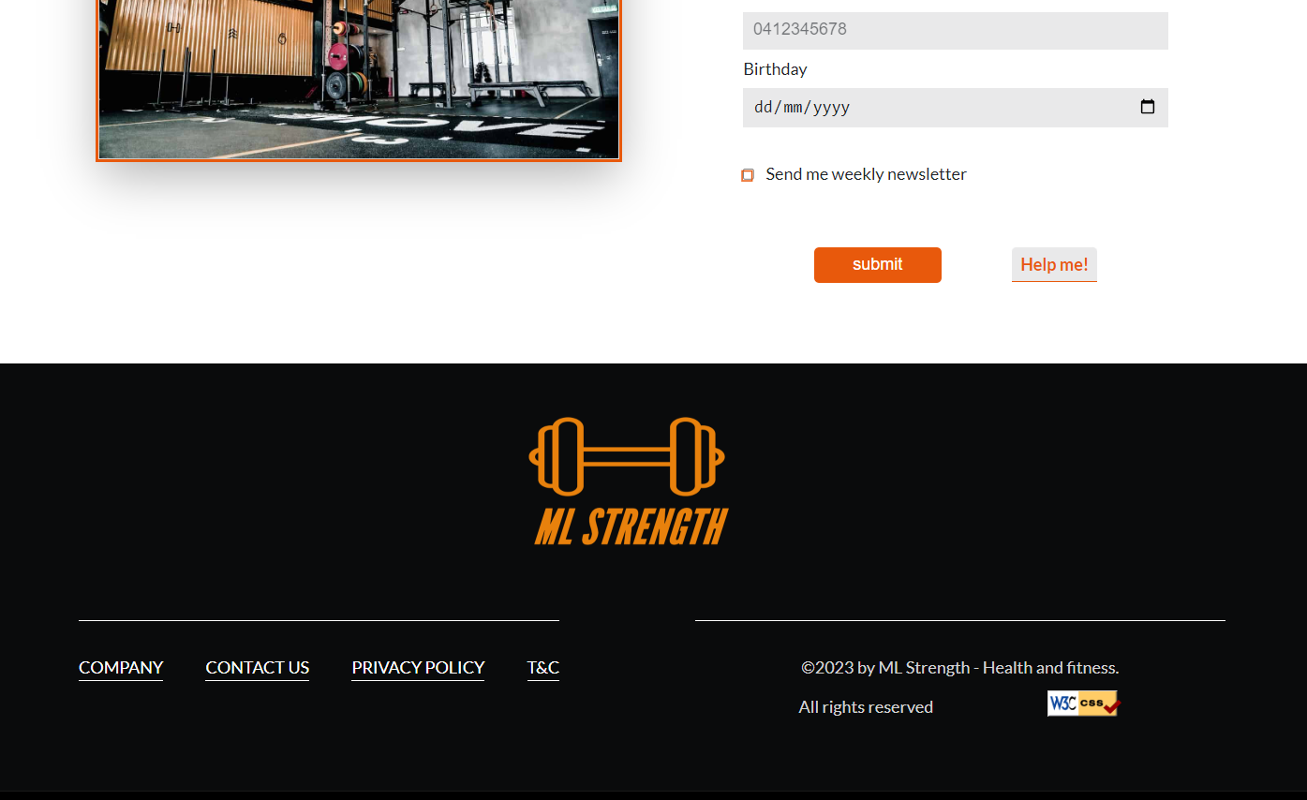

Figure 11 – contact.html -Desktop PC

Google Chrome V 113.0.5672.127 (Official Build) (64-bit)

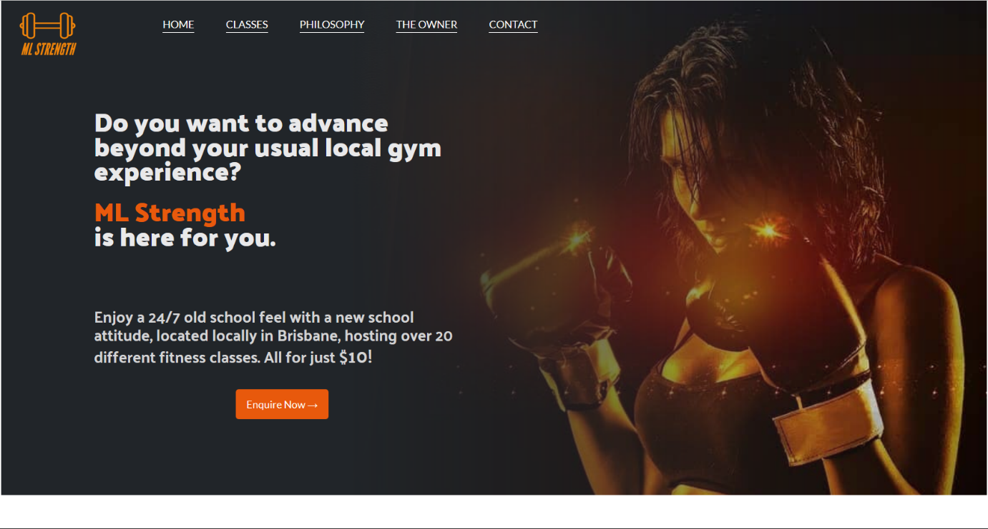

Figure1 – index.html -Desktop PC

Firefox 113.0.1 (64-bit)

Figure 2 – index.html -Desktop PC

Firefox 113.0.1 (64-bit)

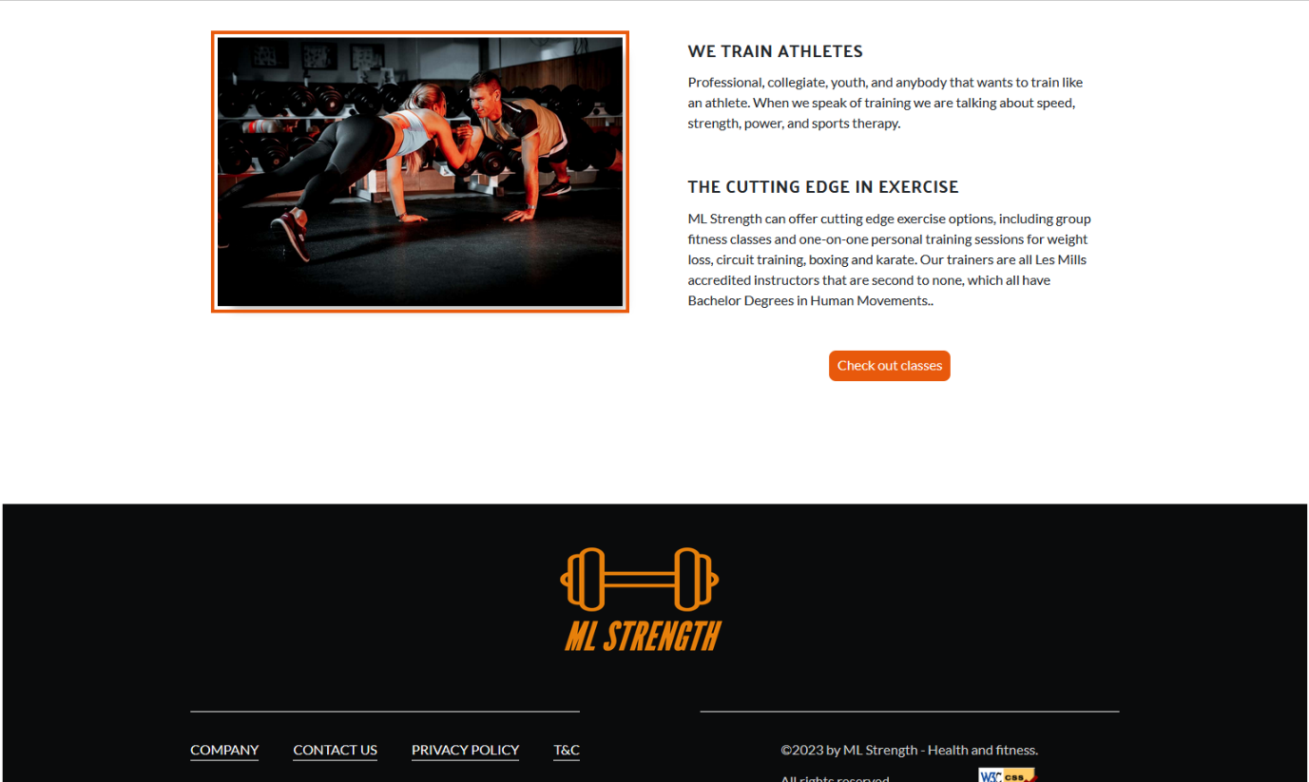

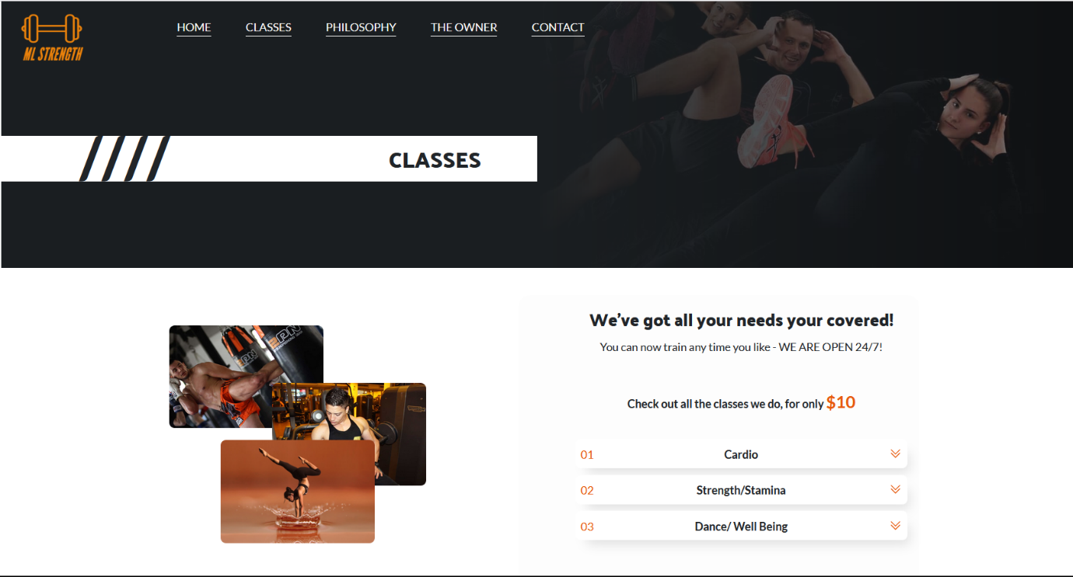

Figure 3 – classes.html -Desktop PC

Firefox 113.0.1 (64-bit)

Figure 4 – classes.html -Desktop PC

Firefox 113.0.1 (64-bit)

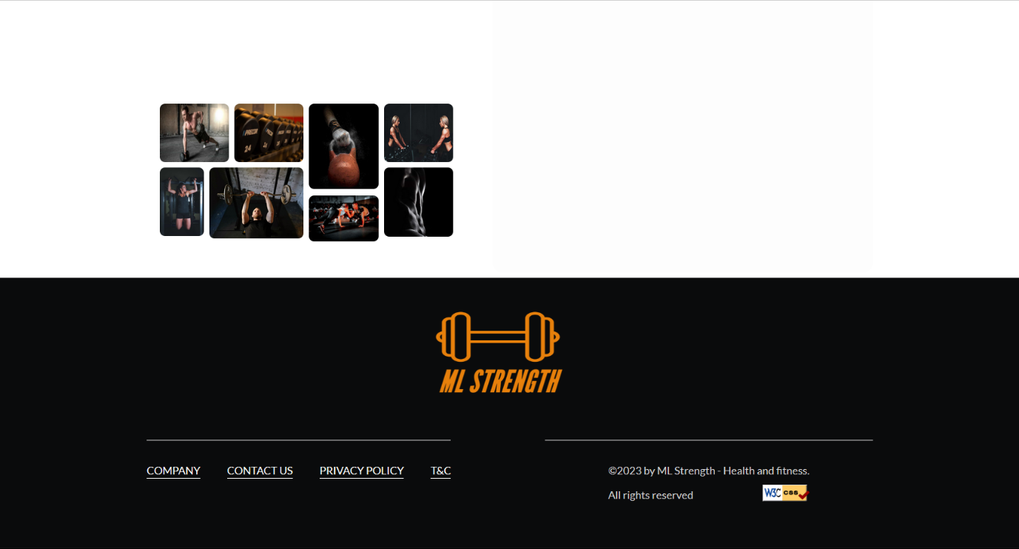

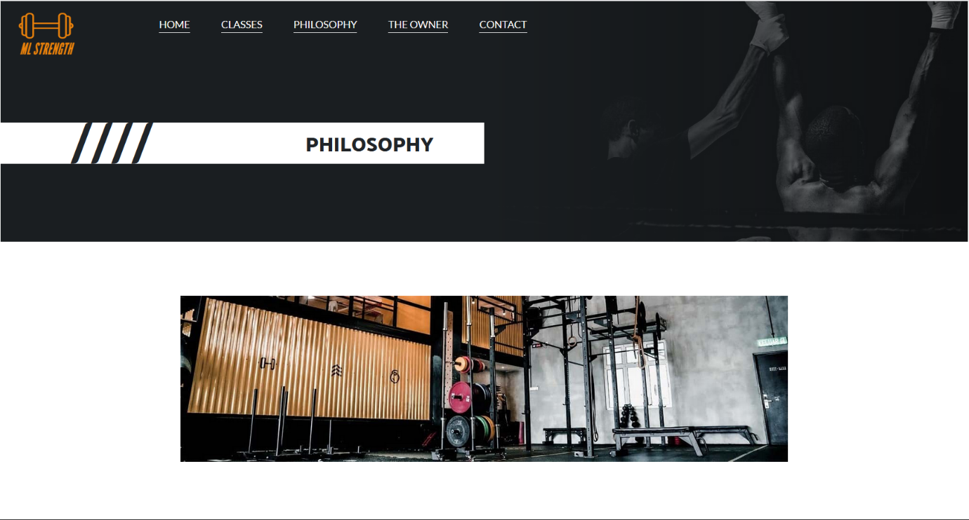Figure 5 – philosophy.html -Desktop PC

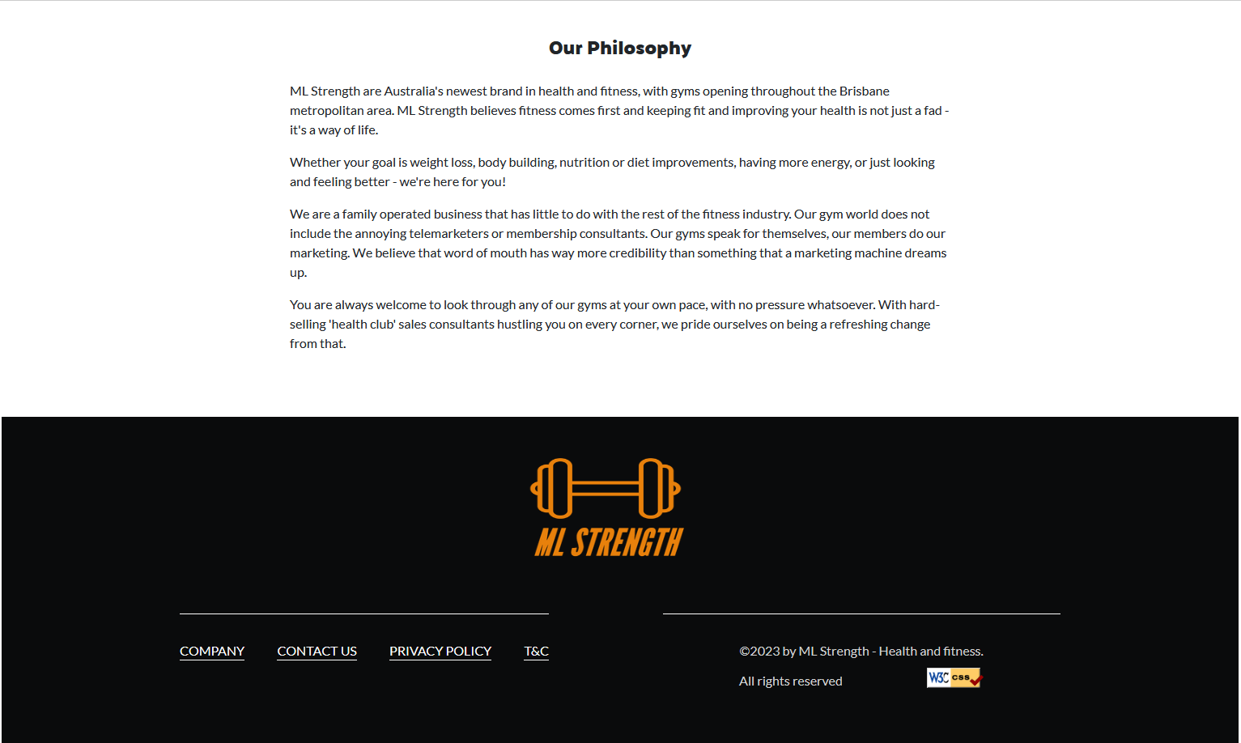Firefox 113.0.1 (64-bit)

Figure 6 – philosophy.html -Desktop PC

Firefox 113.0.1 (64-bit)

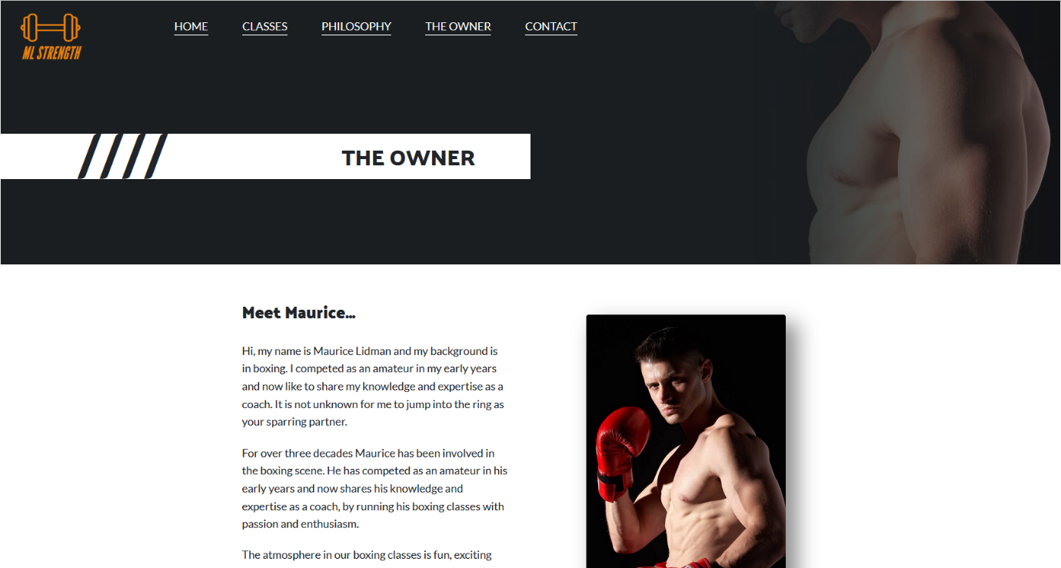

Figure 7 – owner.html -Desktop PC

Firefox 113.0.1 (64-bit)

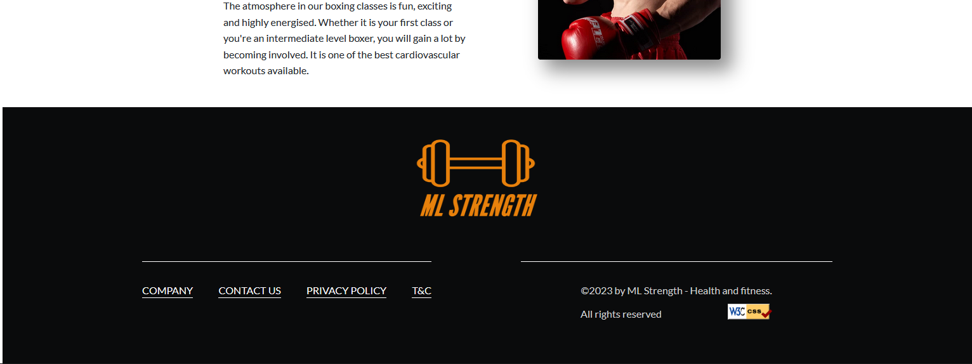

Figure 8 – owner.html -Desktop PC

Firefox 113.0.1 (64-bit)

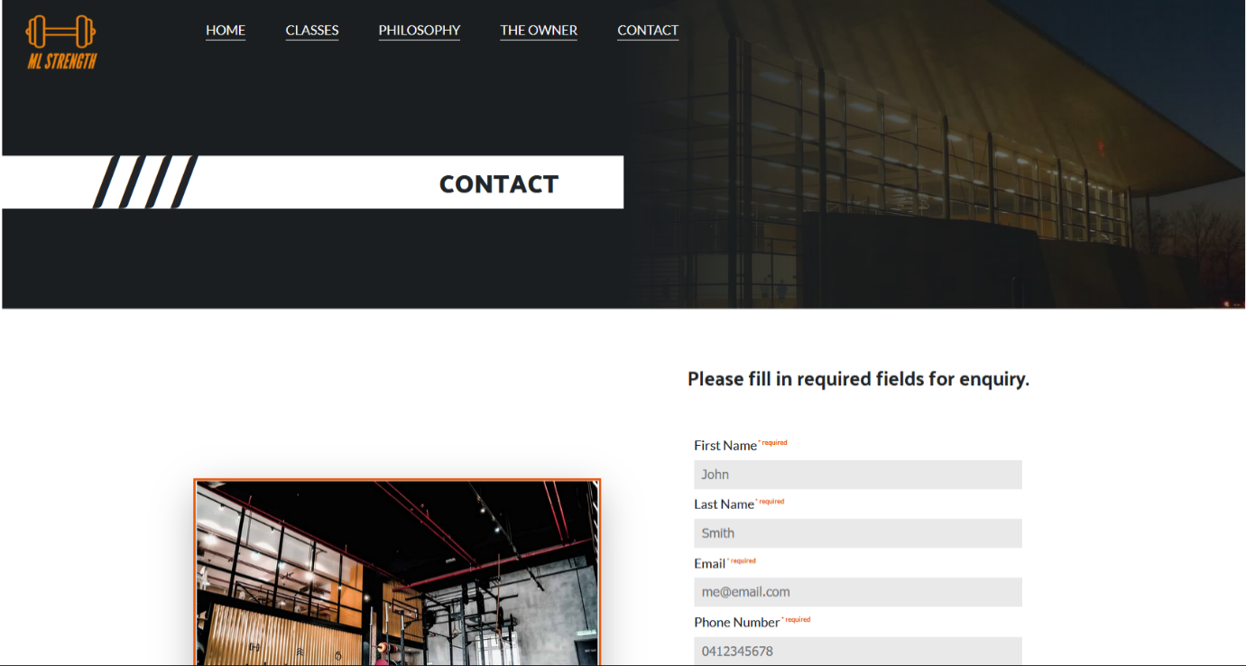

Figure 9 – contact.html -Desktop PC

Firefox 113.0.1 (64-bit)

Figure 10 – contact.html -Desktop PC

Firefox 113.0.1 (64-bit)

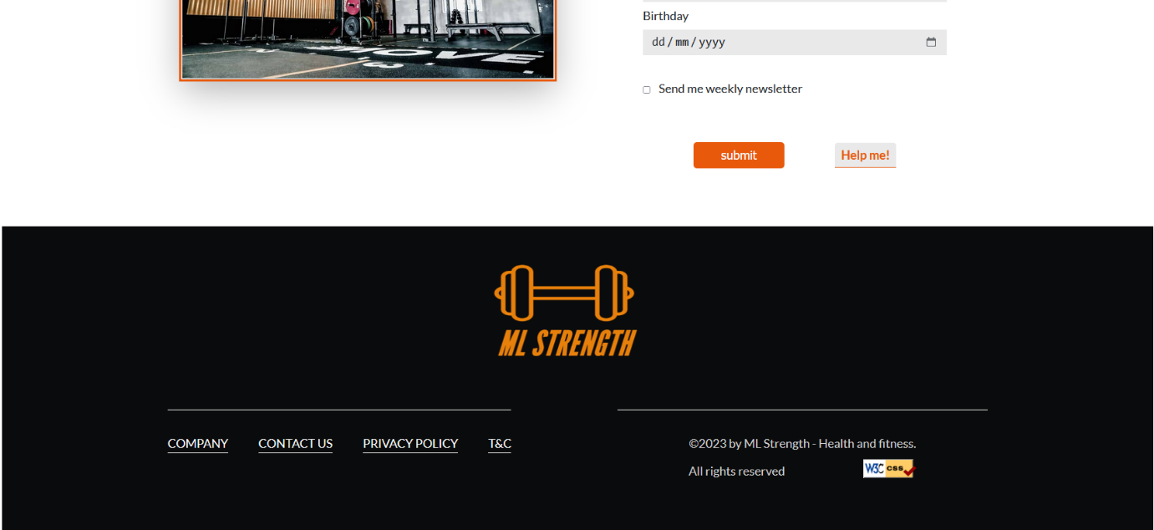

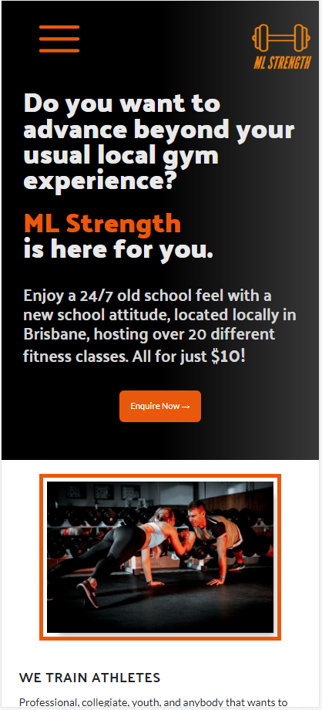

Figure 1 – index.html -Mobile device

Samsung Galaxy s20 ultra

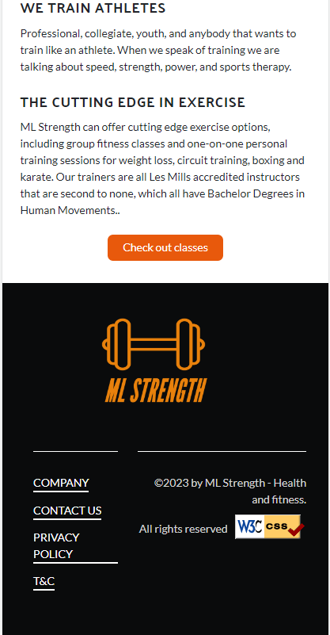

Figure 2 – index.html -Mobile device

Samsung Galaxy s20 ultra

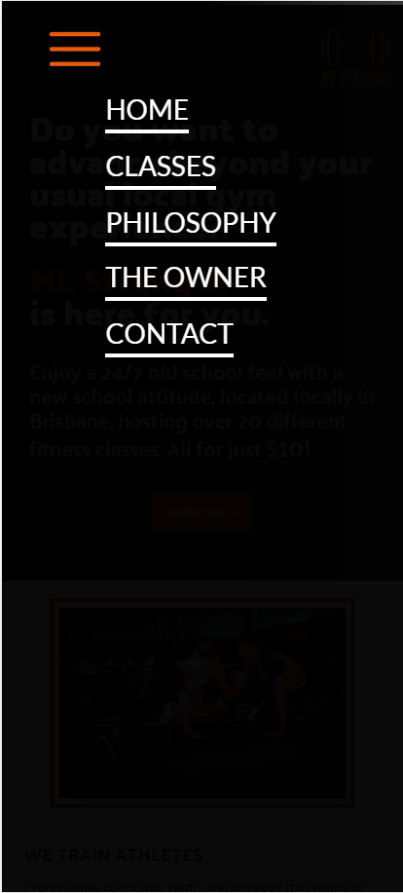

Figure 3 – Menu -Mobile device

Samsung Galaxy s20 ultra

Figure 4 – classes.html -Mobile device

Samsung Galaxy s20 ultra

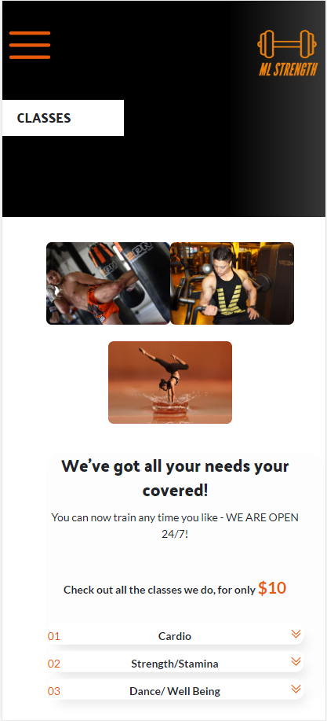

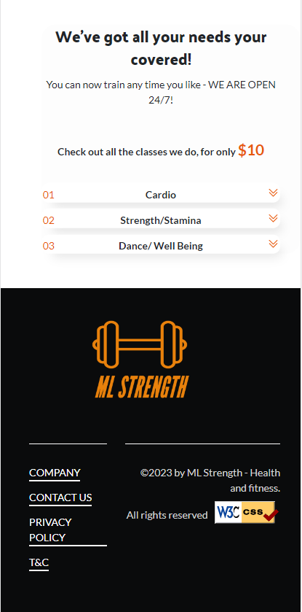

Figure 5 – classes.html -Mobile device

Samsung Galaxy s20 ultra

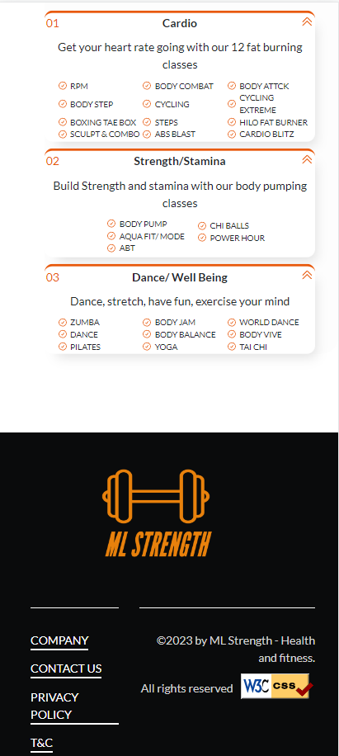

Figure 6 – accordion -Mobile device

Samsung Galaxy s20 ultra

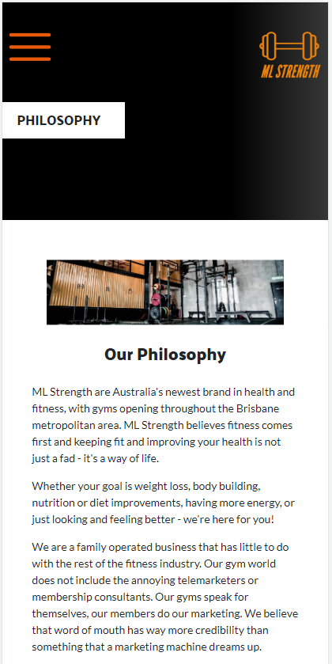

Figure 7 – philosophy.html -Mobile device

Samsung Galaxy s20 ultra

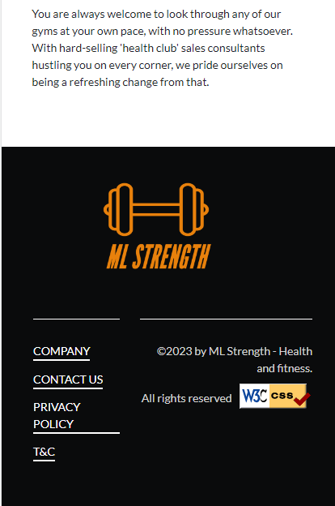

Figure 8 – philosophy.html -Mobile device

Samsung Galaxy s20 ultra

Figure 9 – owner.html -Mobile device

Samsung Galaxy s20 ultra

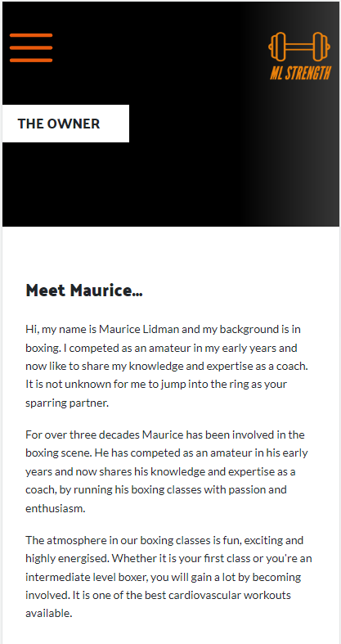

**

Figure 10 – owner.html -Mobile device

Samsung Galaxy s20 ultra

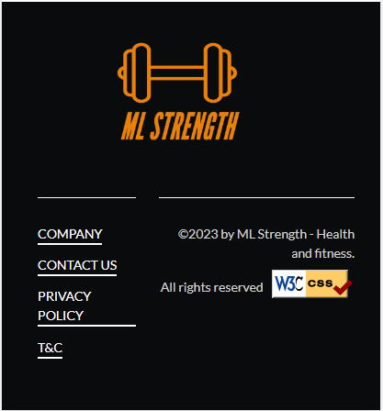

Figure 11 - owner.html -Mobile device

Samsung Galaxy s20 ultra

Figure 12 - contact.html -Mobile device

Samsung Galaxy s20 ultra

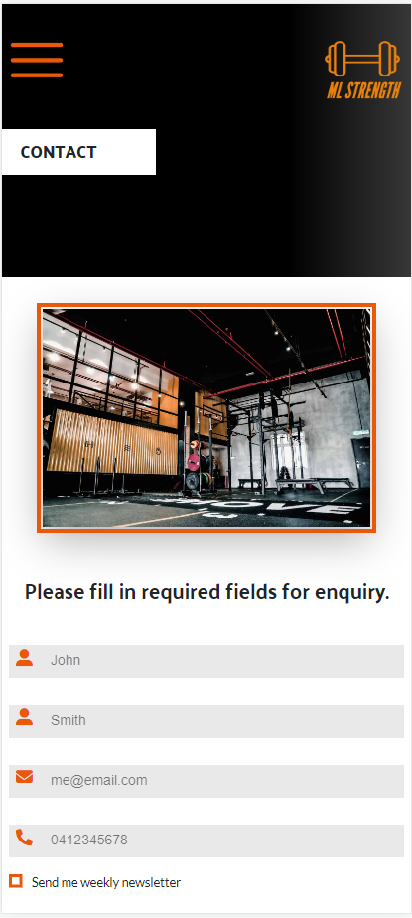

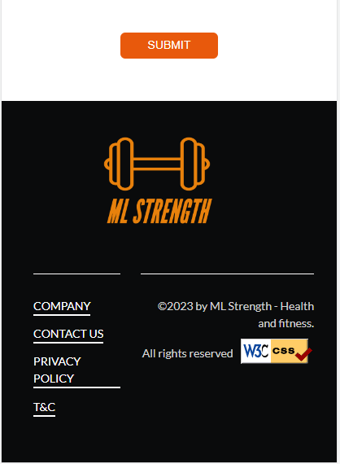

Figure 13 – contact.html -Mobile device

Samsung Galaxy s20 ultra

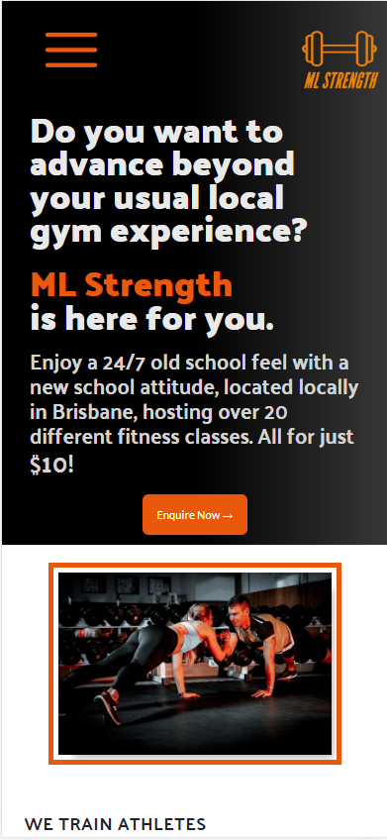

Figure 1 – index.html -Mobile device

iPhone 12 pro

Figure 2 – index.html -Mobile device

iPhone 12 pro

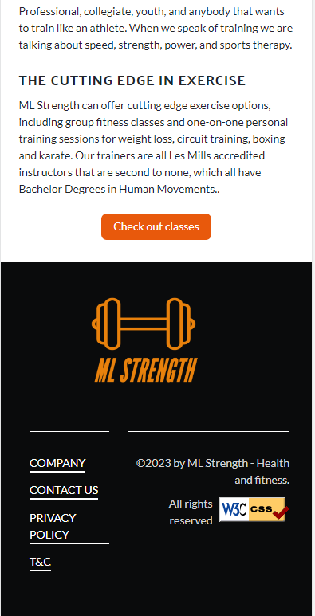

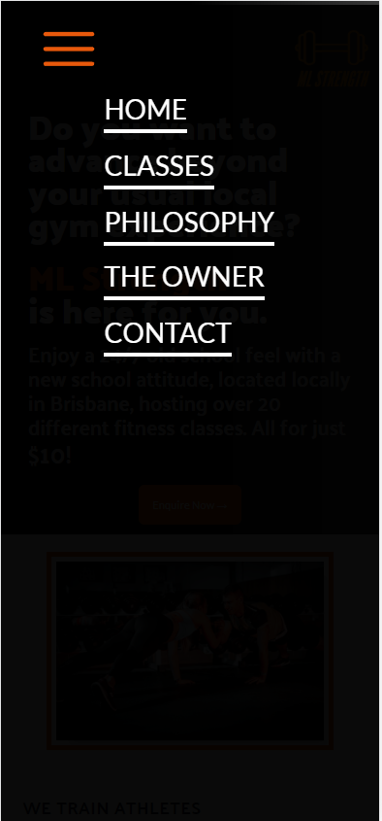

Figure 3 – Menu -Mobile device

iPhone 12 pro

Figure 4 – classes.html -Mobile device

iPhone 12 pro

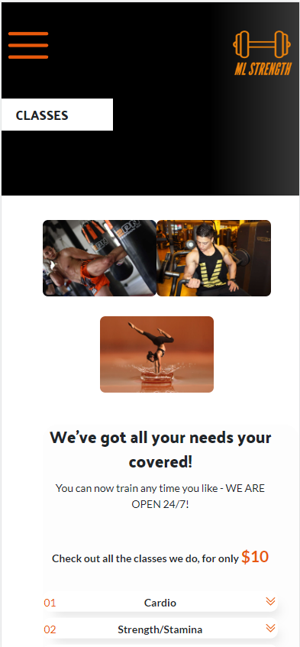

Figure 5 – classes.html -Mobile device

iPhone 12 pro

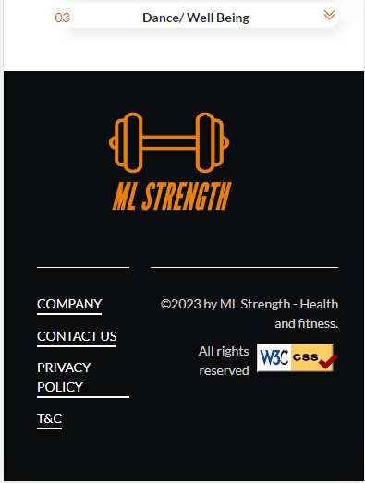

Figure 6 – accordion -Mobile device

iPhone 12 pro

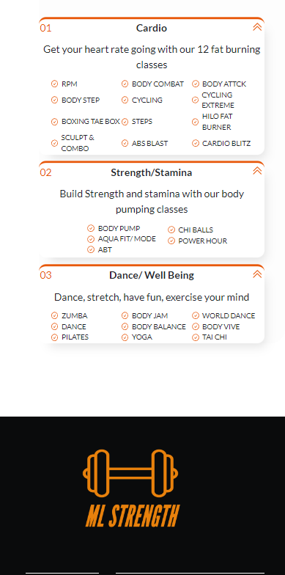

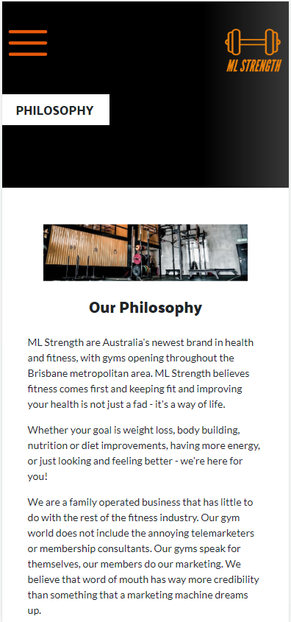

Figure 7 – philosophy.html -Mobile device

iPhone 12 pro

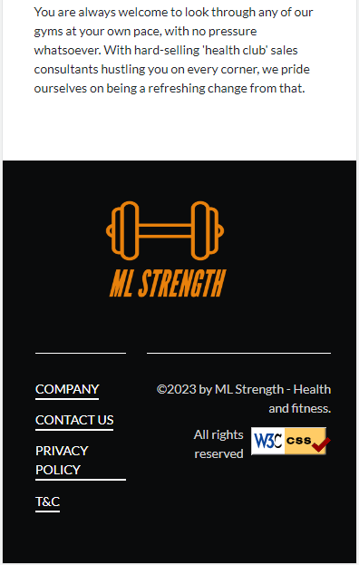

Figure 8 – philosophy.html -Mobile device

iPhone 12 pro

*.*

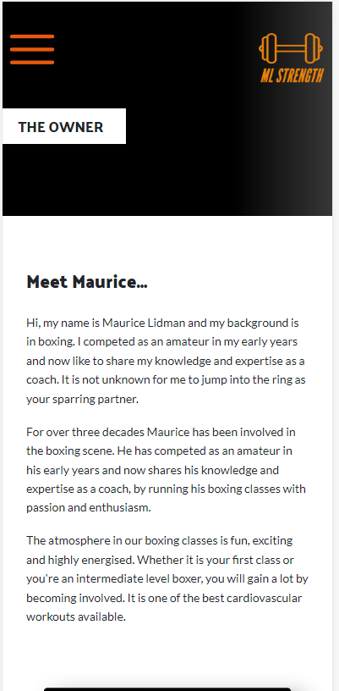

Figure 9 – owner.html -Mobile device

iPhone 12 pro

**

Figure 10 – owner.html -Mobile device

iPhone 12 pro

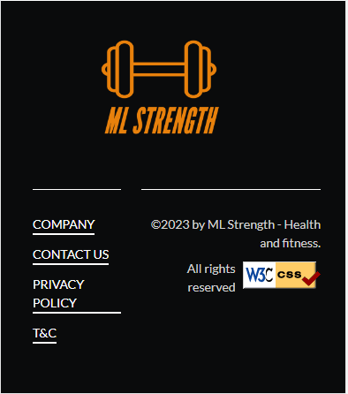

Figure 11 – owner.html -Mobile device

iPhone 12 pro

Figure 12 – contact.html -Mobile device

iPhone 12 pro

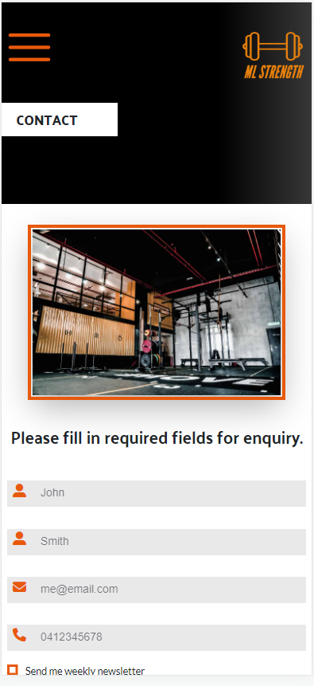

Figure 13 – contact.html -Mobile device

iPhone 12 pro

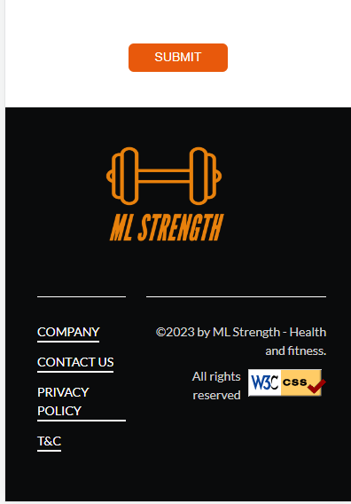

3.6 Accessibility Testing

Index.html Test-1 -FAILED

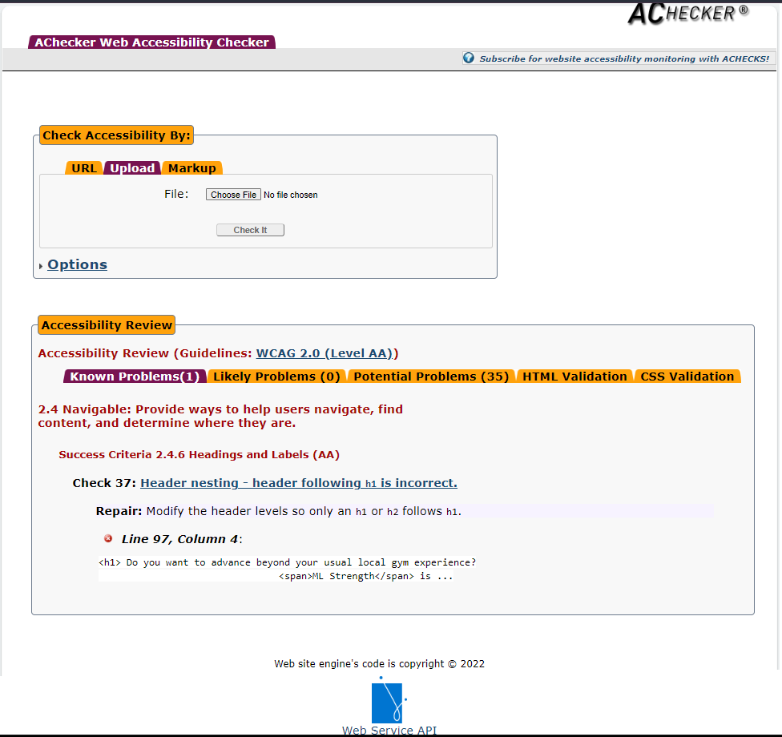

index.html Test-2 - PASSED

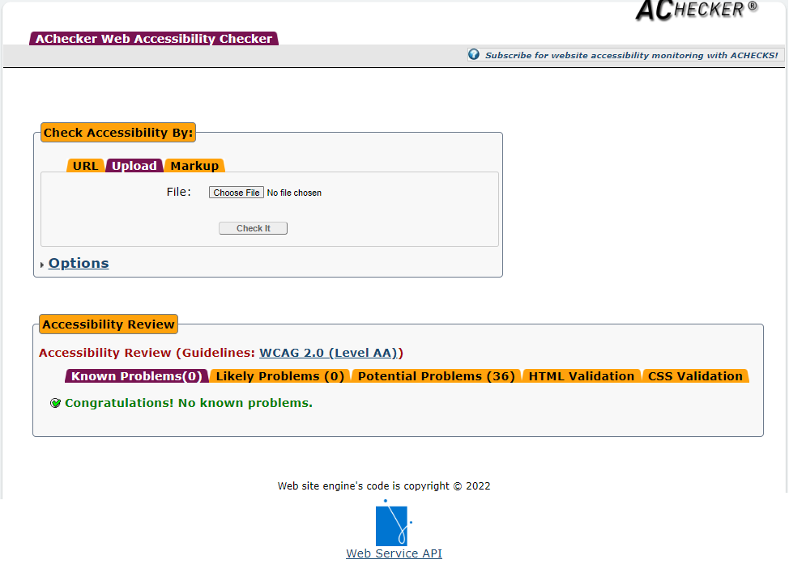

Classes.html Test -1 -FAILED

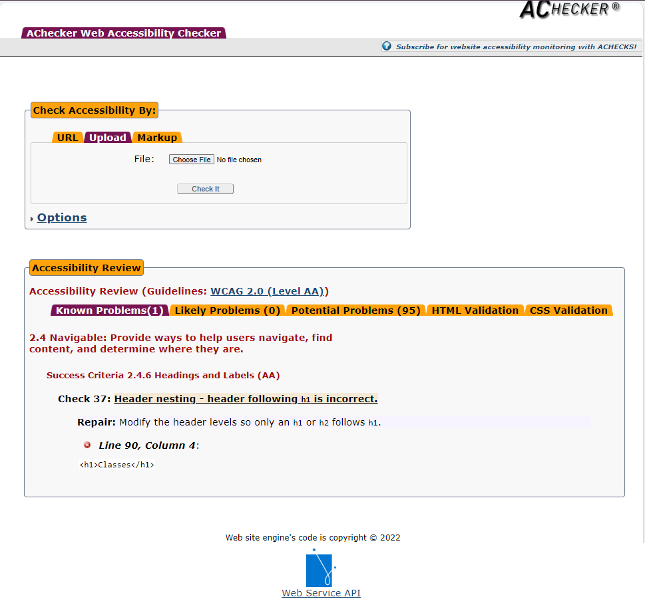

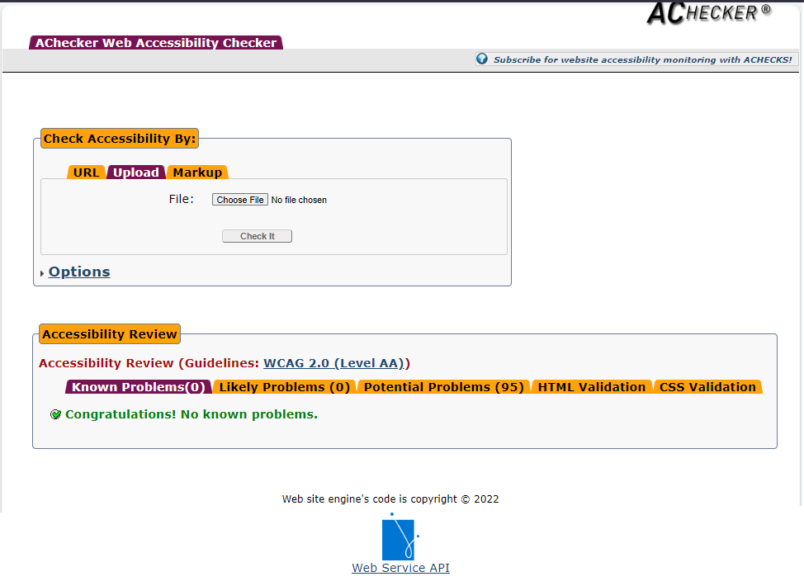classes.html Test -2 – PASSED

Philosophy.html – Test -1 – PASSED

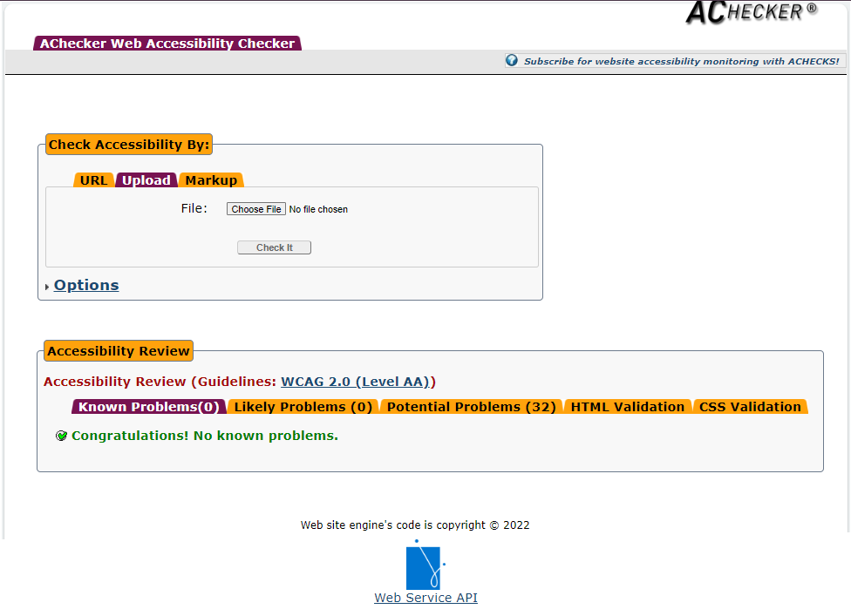

owner.html – Test -1 – PASSED

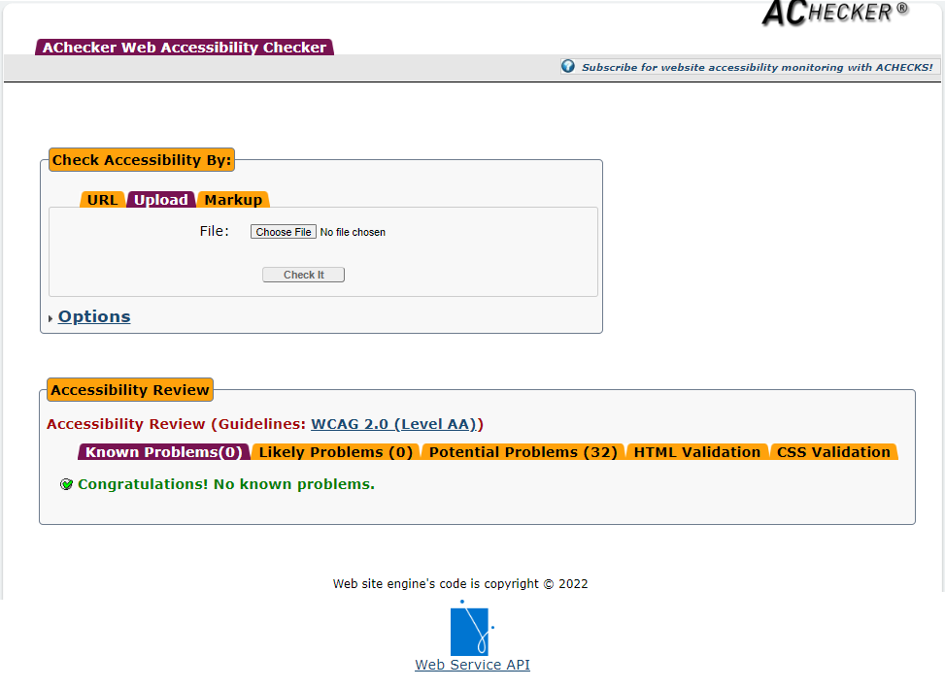

Contact.html – Test-1 – FAILED

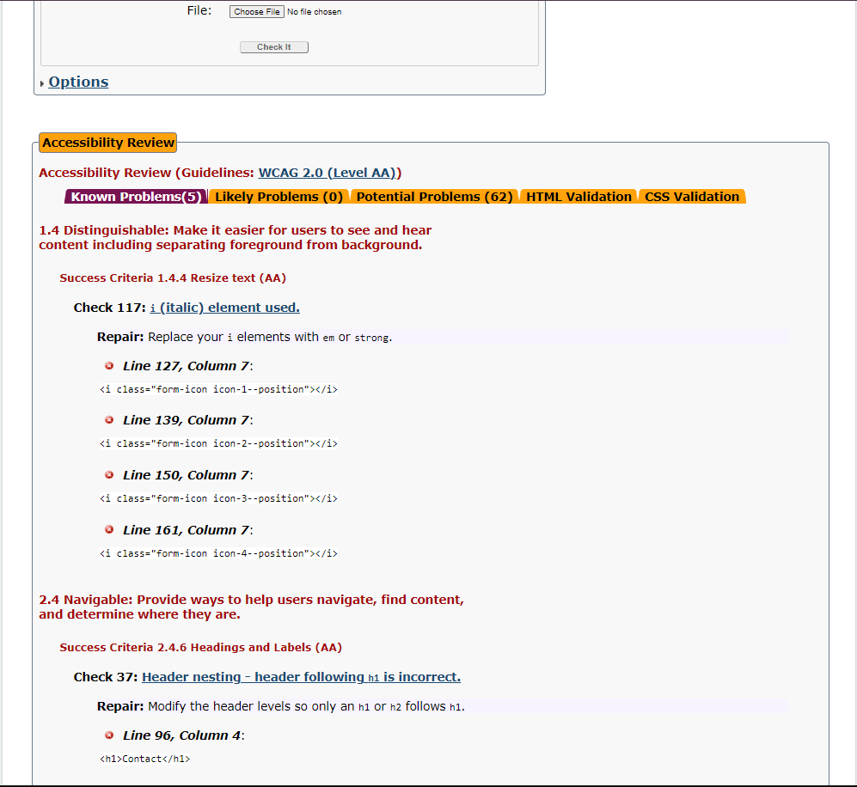

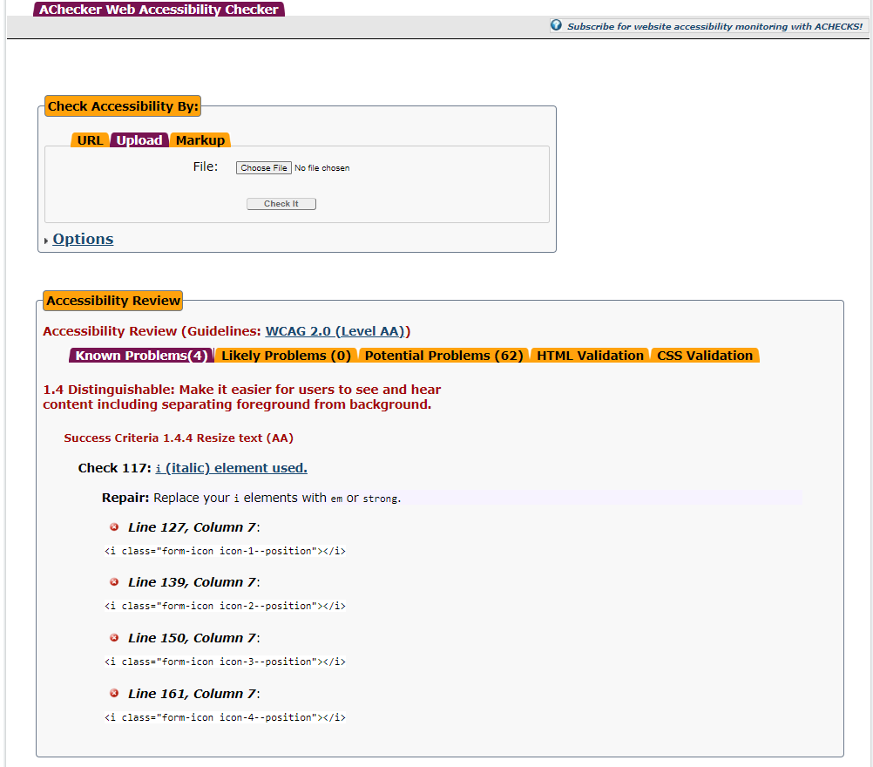Contact.html – Test-2 – FAILED

* Although <i> tag is no longer used for italic emphasis – when using font awesome icons, it needs to be used for the icon styling – so,therefore the <i> tag is not being used for italic emphasis, as the <em> tag would be used, and should pass accessibility testing.

navigation.html – Test -1 _ PASSED

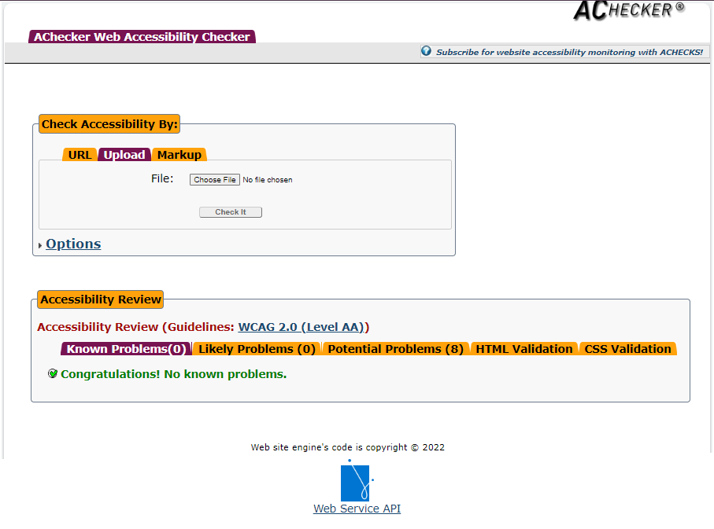

footer.html – Test -1 Passed

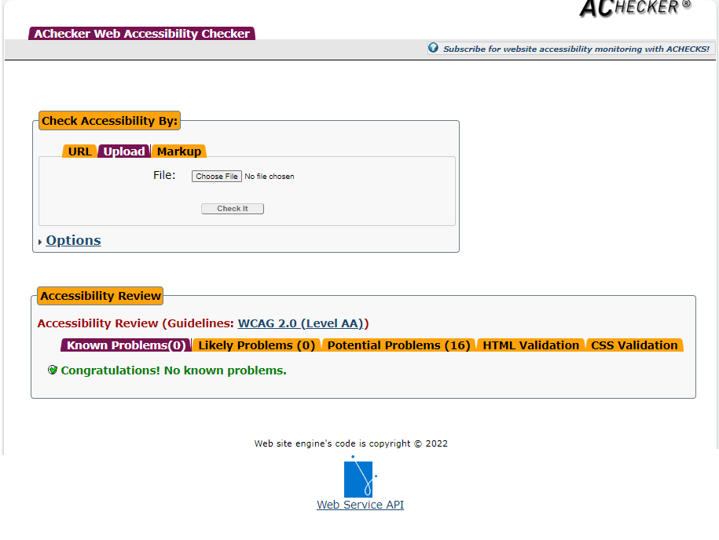

3.7 Cyber security measures

Authentication process

**Two-Factor Authentication**

Add an additional layer of protection to the user/password authentication process by adding 2FA (Two-factor authentication).

2FA verifies a user with two different approaches:

username/password

A phone or device (with an app generated code sent to the phone/device)

**Strong and Unique passwords**

All users on the website should be encouraged to create passwords that are at least 8 characters long, with lower and uppercase letters, numbers and special characters that are difficult for hackers to guess, so making them unique. They should also be encouraged to change these regularly and not use common passwords from other accounts.

Programmatically engineered solutions to avoid cyber-attacks

**Use Parameterised Prepared statements**

Parameterized prepared statements can be named and reused with different parameter values, so theonly variation will be within the parameters, providing more security against SQL injections.

<https://jaredablon-31568.medium.com/how-to-prevent-sql-injection-vulnerabilities-how-prepared-statements-work-f492c369614f>

**Use of firewalls**

These can be used to control incoming and outgoing traffic with the use of predefined network security policies and rules. This can successfully block any unauthorized access attempts and restrict communication.

Internet protocols

**SSL Certificates**

An SSL certificate added to your website ensures a HTTPS (Hyper Text Transfer Protocol Secure) appears in the URL.

This process ensures that any data transmitted between the server and a web browser is secure and cannot be intercepted by third parties.

<https://medium.com/codex/what-is-ssl-for-dummies-eb26161c2b69>

**Internet Protocol Security (IPsec)**

Ipsec can be used remotely to prevent data being intercepted by restricting unauthorized access. This method can be used to create a VPN(virtual private network) which creates a secure communication which also encrypts network traffic.

Project Signoff

|  |  |
| --- | --- |
| **PROJECT SIGNOFF**  Signing off on this document signifies that the client representative is satisfied with the completed project. The client acknowledges satisfaction and completion with all elements of the project. | |
| Client Representative Signature:  Date: 2/06/2023 | Developer Signature:  Date: 2/06/2023 |
| **PROJECT NOT APPROVED**  Please provide feedback below and attach any relevant information to assist the project team in making the changes needed. | |

Appendices

References